

**A PROJECT REPORT**

**ON**

**Real-Time Data Processing and Analytics System for Live Video Content Moderation**

A project report submitted in partial fulfillment of the requirements for the degree of Bachelor of Technology in Computer Science & Engineering

BACHELOR OF TECHNOLOGY COMPUTER SCIENCE & ENGINEERING

Submitted By

Om Barde 21070521103  
Deepankar Dhawale 21070521112

Om Bansod 21070521110

UNDER THE GUIDANCE OF

Dr. Latika Pinjarkar

Associate Professor

Academic Incharge

Symbiosis Institute of Technology, Nagpur Campus

**DEPARTMENT OF COMPUTER SCIENCE & ENGINEERING**

**AY 2024-25**



**DEPARTMENT OF COMPUTER SCIENCE & ENGINEERING**

**CERTIFICATE**

This is to certify that the Project work entitled “**Real-Time Data Processing and Analytics System for Live Video Content Moderation**” is carried out by the **Om Barde, Deepankar Dhawale, Om Bansod** in partial fulfillment for the award of the degree of **Bachelor of Technology** in **Computer Science & Engineering**, Symbiosis International (Deemed University), Pune during the academic year 2024-2025.

|  |  |  |
| --- | --- | --- |
|  |  |  |
| Dr. Latika Pinjarkar  Associate Professor  Project Guide |  | Dr. Latika Pinjarkar  Associate Professor  Academic Incharge |
|  |  |  |

## DECLARATION

We hereby declare that the project titled “**Real-Time Data Processing and Analytics System for Live Video Content Moderation**” submitted to Symbiosis Institute of Technology, Constituent of Symbiosis International (Deemed University) Pune for the award of the degree of Bachelor of Technology in Computer Science & Engineering is a result of original research carried out by me. We understand that my report may be made electronically available to the public. It is further declared that the project report or any part thereof has not been previously submitted to any University or Institute for the award of any degree or diploma.

|  |  |  |
| --- | --- | --- |
| Name: Om Barde | Name: Deepankar Dhawale | Name: Om Bansod |
| PRN: 21070521103 | PRN: 21070521112 | PRN: 21070521110 |

Degree: Bachelor of Technology in CSE

Department: Computer Science & Engineering

Title of the project : Real-Time Data Processing and Analytics System for Live Video Content Moderation

|  |  |  |
| --- | --- | --- |
| Om M Barde | Deepankar R Dhawale | Om Y Bansod |

(Signatures of the Students)

Date:

## ACKNOWLEDGEMENT

we want to express my sincere gratitude to everyone who supported us throughout this project. First and foremost, we would like to thank my project guide, **Dr. Latika Pinjarkar**, for his valuable guidance, encouragement, and feedback. She has been a constant source of inspiration and motivation for us.

We would also like to thank the In-charge academics department, **Dr. Latika Pinjarkar**, for providing us with the necessary facilities and resources for conducting this project. We are grateful to her for her constant support and advice.

We are thankful to **Prof. (Dr) Nitin Rakesh** Director SIT Nagpur for his continuous support and encouragement throughout the project work.

We want to acknowledge the contribution of our project team members, who have worked hard and cooperated with us in every project stage. They have been accommodating and supportive throughout this journey.

We would also like to thank our family and friends for their love, care, and support. They have always been there for us in times of need and stress. They have encouraged us to pursue my passion and achieve our goals.

Lastly, we thank **Symbiosis Institute of Technology Nagpur** for allowing us to work on this project and enhance our skills and knowledge. proud to be a part of this prestigious institution.

## ABSTRACT

The rise of live streaming platforms like YouTube and Twitch has reshaped the digital content landscape, enabling creators to engage audiences worldwide in real time. While this transformation has revolutionized communication, entertainment, and education, it has also introduced significant challenges in content moderation. Textual elements within live video streams can often include sensitive or harmful content, such as offensive language, personal identifiers, or promotional spam. The dynamic nature of live streams complicates moderation, as text may appear momentarily, in motion, or in varying orientations and formats, demanding advanced, real-time solutions.

This project addresses these challenges by developing a robust real-time text detection and moderation system tailored specifically for live streaming environments. The system employs EasyOCR, a state-of-the-art optical character recognition (OCR) tool, to detect textual content embedded in video frames with high accuracy. To ensure real-time performance, GPU acceleration is implemented using CUDA, enabling the processing of high-resolution video frames with minimal latency. By focusing on predefined word lists and patterns rather than static datasets, the system ensures adaptability to evolving requirements, making it capable of dynamically identifying and moderating sensitive text.

The project is exclusively designed for YouTube and Twitch, ensuring that its implementation aligns with the technical and operational requirements of these platforms. By addressing the unique challenges of text moderation in live video streams, this system contributes to safer and more responsible digital communication environments. Its ability to operate efficiently under high-load conditions demonstrates the potential of combining advanced OCR technology and GPU acceleration for real-time applications in the rapidly evolving live streaming domain.

Keyword: Live streaming, text moderation, EasyOCR, GPU acceleration, CUDA, Gaussian blur, YouTube, Twitch, real-time detection, sensitive content, optical character recognition, video processing, content moderation, deep learning, real-time processing, live video analysis, ethical standards, platform compliance.

## TABLE OF CONTENTS

|  |  |  |
| --- | --- | --- |
|  | | Page |
| **Certificate** | | i |
| **Declaration** | | ii |
| **Acknowledgment** | | iii |
| **Abstract** | | iv |
| **Table of Contents** | | v |
| **List of Tables** | | vii |
| **List of Figures** | | viii |
| **List of Abbreviations** | | ix |
| **CHAPTER 1: INTRODUCTION** | | 1 |
| 1.1 | Introduction | 1 |
| 1.2 | Problem statement | 4 |
| 1.3 | Scope of research | 8 |
| 1.4 | Research hypothesis | 9 |
| 1.5 | Objectives | 10 |
| 1.6 | Organization of the report | 10 |
| **CHAPTER 2: LITERATURE REVIEW** | | 12 |
| 2.1 | Background | 12 |
| 2.2 | Summary of literature review and research gap | 71 |
| **CHAPTER 3: SOFTWARE REQUIREMENTS SPECIFICATION** | | 20 |
| 3.1 | Software Tool Platform/ Tools/Framework used | 20 |
| 3.2 | Hardware tools | 26 |
| 3.3 | Work Breakdown Structure | 33 |
| 3.4 | Functional Requirements |  |
| 3.5 | Non Functional Requirements |  |
| 3.6 | Project Cost Estimation |  |
| **CHAPTER 4: METHODOLOGY** | | 48 |
| 4.1 | Dataset Collection and Preprocessing | 48 |
| 4.2 | Model Development and Training | 51 |
| 4.3 | Real-Time System Integration | 53 |
| 4.4  4.5  4.6  4.7  4.8  4.9  4.10  4.11  4.12  4.13  4.14 | Optimization and Deployment  Overview of the System Architecture  Challenges and Solutions  Tools and Technologies  Advantages of the Methodology  System Structure and Overview  Execution of Apache Kafka  Implementation of Apache Flink  Advanced Configurations  Kafka Consumer: Frame Receiver and Decoder  Outcome | 54  54  62  62  62  62  63  67  69  69  71 |
| **CHAPTER 5: RESULTS AND DISCUSSION** | | 72 |
| 5.1  5.2  5.3  5.4  5.5  5.6  5.7  5.8  5.9  5.10  5.11  5.12 | Overview of Results  Quantitative Analysis  Qualitative Observations  Performance Benchmarks  Comparative Analysis  Limitations  Discussion  Kafka results  Challenges and Solutions  Additional Insights  Outcomes  Summary of Results and Discussion for image detection | 72  72  73  74  75  75  75  76  78  79  79  80 |
| **CHAPTER 6: CONCLUSION AND FUTURE SCOPE** | | 90 |
| 6.1 | **Conclusion for apache kafka** | 90 |
| 6.2  6.3  6.4  6.5  6.6 | Future Scope  **Conclusion for Image detection**  **Future Scope**  **Conclusion for text detection**  **Future Scope** | 91  94  95  98  99 |
| **REFERENCES ( in IEEE format only)** | |  |
| **APPENDICES** | |  |
|  | AIC Form **(Mandatory)** |  |
|  | Similarity Report **(Mandatory)**  AI Plag Report **(Mandatory)** |  |
|  | Research Paper (Draft/published) |  |
|  | Certificate from Industry (if any) |  |
|  | Project Competition Certificate (if any) |  |
|  | Evidence of other project outcome (if any) |  |

## LIST OF TABLES

|  |  |  |
| --- | --- | --- |
|  |  | **Page** |
| Table 3.1 | Estimated cost of project | 47 |
| Table 5.1 | Comparative Analysis of Proposed System and Existing Systems | 76 |

## LIST OF FIGURES

|  |  |  |
| --- | --- | --- |
|  |  | **Page** |
| Figure 1.1 | Overview of Confluent Dashboard Interface | 2 |
| Figure 2.1  Figure 2.2  Figure 2.3  Figure 3.1  Figure 3.2  Figure 3.3  Figure 3.4  Figure 3.5  Figure 3.6  Figure 3.7  Figure 3.8  Figure 4.1  Figure 4.2  Figure 4.3  Figure 4.4  Figure 4.5  Figure 4.6  Figure 4.7  Figure 4.8  Figure 5.1  Figure 5.2  Figure 5.3  Figure 5.4  Figure 5.5  Figure 5.6 | Evolution of OCR  Precision-Recall Curve showcasing the detection system's accuracy at varying thresholds.  Training and Validation Loss Curve highlighting model convergence over time.  comparative analysis of OCR tools used for text detection.  Software tools and framework integration flowchart  Live cluster information showcasing Kafka and Flink integration.  Cluster settings for performance optimization.  Cluster Settings showcasing Kafka and Flink configurations.  Flowchart for hardware requirements and roles  Topic Message Flow diagram illustrating the flow of messages between Kafka producers and Flink consumers.  Topic Configuration setup showcasing partitioning, replication, and fault tolerance settings.  Dataset for model training  Object detection  Training and validation losses with precision, recall, and mAP metrics over epochs.  A confusion matrix showcasing the system’s performance, indicating true positives, false positives, and false negatives for weapon detection.  A precision-recall curve demonstrating the system’s effectiveness across various confidence thresholds.  A bar chart comparing key challenges and the effectiveness of solutions implemented in text and weapon detection.  Cluster Overview  Topic Overview  Precision recall curve  F1-Confidence curve  Recall-Confidence Curve  Precision-Confidence Curve  Detecting the objects  Blurring the detected objects | 14  15  16  21  21  26  26  29  31  44  45  50  53  54  57  58  61  65  67  83  83  84  84  86  89 |

## LIST OF ABBREVIATIONS

|  |  |
| --- | --- |
| OCR | Optical Character Recognition |
| GPU | Graphics Processing Unit |
| CUDA | Compute Unified Device Architecture |
| VM | Virtual Machine |
| API | Application Programming Interface |
| AWS | Amazon Web Services |
| YOLO | You Only Look Once |
| COCO | Common Objects in Context |
| NLP | Natural Language Processing |
| FPS | Frames Per Second |
| EC2 | Elastic Compute Cloud (AWS) |
| S3 | Simple Storage Service (AWS) |
| RBAC | Role-Based Access Control |
| mAP | Mean Average Precision |
| GDPR | General Data Protection Regulation |
| SSL | Secure Sockets Layer |
| SASL | Simple Authentication and Security Layer |
| JSON | JavaScript Object Notation |
| YAML | Yet Another Markup Language |
| CNN | Convolutional Neural Network |

**Chapter 1**

**Introduction**

**1.1 Introduction**

With the increased live streaming platforms like YouTube or twitch, the growth rate of them is through the roof. has made significant improvements in modes in which content is disseminated and received in the World Wide Web. These platforms have evolved as popular, pervasive, versatile, and important tools of social interaction, leisure, learning, and expression where ideas creators unprecedented and unique chance to communicate with people from other states and countries in real mode.

However, it has come with many problems which affect its growth, especially in the following areas: user protection, privacy and to meet the standards of ethicality and the platform. guidelines. Sometimes you see someone live streaming, and they reveal personal details of their lives without realizing it. This will make it easier for the bad actors to use these platforms to post toxic or misleading information. Solving these tasks involves proving complex, immediate decisions and depending on particular MeiningThe problems mentioned above cannot be solved without high level and real time solutions that are able to The next criterion is the capacity to identify threats as well as acting on them while as little time as possible. This project proposes a ambitious physical framework that employs complicated solutions like Apache Kafka.

We use EasyOCR, and YOLO for text recognition and detection, respectively, to ensure content moderation in live streams is effectively done. The system protects learners from exposure to, and minimizes the potential creation of, material that is not suitable for their age – textual, graphical, or even within the context of a learning package. The focal elements of websites, or web page content, and other forms of user-generated content, such as blogs and comments, as well as URL |metadata| is real-time identified and moderated.

**Real-Time Data Streaming and Analytics**

Leveraging Apache Kafka as a solution, this is a complex platform for the efficient transfer of high throughput and low latency data streaming. Due to this efficiency, it is capable of consuming and analyzing large amounts of data as it is produced; this makes live streaming environments platform-responsive. Accompanying Kafka is Apache Flink and the latter is a system designed for efficient real-time data processing and analysis. The stateful processing of streams makes Flink perfectly suitable for processing extensive event-oriented applications such as real-time sentiment analysis of streaming metadata and making of fraud cases.

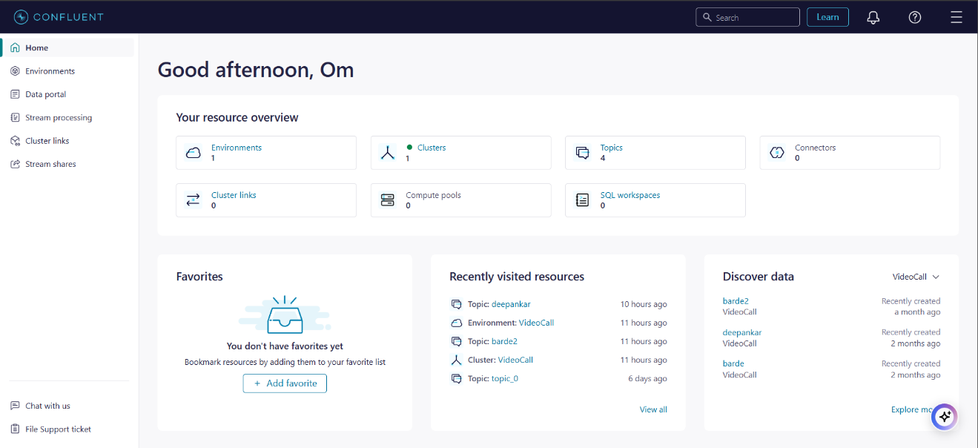

Figure 1.1: Overview of Confluent Dashboard Interface

**Real-Time Text Detection**

It is common that the text embedded in the middle of a stream of live video streams often has a sensitive or inappropriate content such as words of offence, personal positions, or even promotional message. While text in live streams may not appear static, they may be fleetingly, in motion, and in a variety of formats, so detection is significantly more difficult. The augmented system, with GPU acceleration via CUDA, quickens processing of large high resolution frames with minimal latency. This method helps us accurately detect textual content in multilingual contexts. On the platform specific moderation policies, sensitive text is dynamically blurred with Gaussian blur to preserve privacy. The system does not rely on static dataset, instead it uses predefined word lists and patterns for real time adaptability to new trends and new language variations of the time content moderation.

**Real-Time Visual Detection**

Beside aims to enable text detection in addition to the critical requirement of visual content moderation, with a focus on detection of weapons in live video streams. The project takes advantage of the latest computer science developments, including artificial intelligence and computer vision, and uses a state of the art object detection model that is known for being fast and accurate: YOLO (You only look once). In order to make YOLO perform better, the project applies transfer learning, adaptive frame processing and detection smoothing. Adaptive frame processing adjusts the processing rate dynamically depending on what the system detects, as does transfer learning, which makes sure that the system is tuned to detect guns, for example.

With this robust integration, we make sure sensitive content is consistently detected and real time blurred, setting a standard for content detection and real time blurring of sensitive content that is compliant with platform guidelines and keeps user safety first. The system addresses real time performance lags and tracking inconsistencies by dynamically processing video streams and blurring identified weapons in an effort to achieve computational efficiency.

**Holistic Moderation for Live Streaming Platforms**

Through the combination of Apache Kafka for efficient multi data stream, EasyOCR for real time text detection and YOLO for visual content analysis, we achieve a complete solution for live streaming environments. It makes scaling and adaptability in terms of apparent technical and user specific needs in platforms like YouTube and Twitch. By incorporating state of the art machine learning models and streaming technologies, the system presents a paradigm of how to make moderating live video streams safe, private and conformant with regulatory requirements in the digital communication age.

**1.2 Problem Statement**

Due to live streaming platforms like YouTube and Twitch, content is now created, consumed, and interacted with ‘real time’. Definitely, these platforms have changed the way of communication and engagement in digital space, however, also pose major challenges in maintaining a healthy, lawful, and engaging spaces for users. Live streams may have harmful content, namely with offensive language, personal info, spam or even weapons demonstrations — all this can jeopardise user safety and platform integrity.

**Challenges in Moderation**

Today, traditional content moderation methods are particularly reactive, depending on manual intervention or static datasets, and allow harmful content to spread before they can respond. However, these methods tend to fail working in the vivid, live streaming scenario, where inconsistent offensive and sensitive content may appear in the blink of an eye, or in various forms. Key challenges include:

1. **Textual Content**: Live video streams can contain text with offensive language, personal identifiers, or information that is against the platform guideline. As systems evolve, slang changes, languages emerge, and the text changes orientation, current systems have difficulty adapting.
2. **Visual Content**: More and more weapons related incidents only strengthens the case that we need systems that are able to detect weapons such as guns in live streams accurately and fast. Conventional models face difficulties with:
   * **Accuracy**: Limited training datasets or class imbalances leading to misclassification.
   * **Performance**: In particular, real time processing is computationally expensive and demands of the traditional systems to meet the constraints of both high resolution video feeds.
   * **Tracking**: They provide inconsistent detection, with flickers of bounding boxes and loss of focus.
3. **Metadata and Analytics**: There are no robust frameworks to process and analyze accompanying metadata in real time that could support sentiment analysis, fraud detection and real time event driven intelligence.

**Need for Real-Time, Scalable Solutions**

In platform such as YouTube and Twitch, which base there business model on interaction with the user temporal nature of moderation defeats its main purpose of protecting users and eroding the reputation of the platform. Many existing solutions built using conventional datasets and depending on user interferences can work inefficiently within live streaming environment reflecting its truly dynamic nature.

In response to these challenges, this project outlines the implementation of a real-time automated system that encompasses text detection, video content analysis as well as metadata analysis. In this work, Apache Kafka, which is powerful in high-throughput data streaming, EasyOCR with multilingual text detection, and YOLO with weapon detection are deployed to provide a high performance and low latency solution for live streaming platforms.

**1.3 Scope of Research**

This work targets at the proposal and inclusion of an actual-time mechanism that could facilitate dynamic safety, conformity and user anonymity throughout live broadcasts. The project is centered on three primary areas: real-time data streaming, textual content such as classification, filtering and recognition, and content with visuals identification. Some of the tools used in is System include Apache Kafka, EasyOCR, and YOLO to capture what is needed for live streaming applications like YouTube and Twitch.

**Real-Time Streaming Technologies**

This work investigates the quality of Apache Kafka for real-time data streaming and Apache Flink for data stream processing. These are important in considering the large and ever changing nature of live stream data to be managed. Key areas of investigation include:

* **Data Streaming and Processing**: Using Kafka and Flink to guarantee near real-time processing of streaming metadata’s ingestion and actual analysis.
* **Advanced Analytics**: Performing tasks such as sentiment analysis and fraud detection to extract actionable insights from metadata.
* **Scalability and Fault Tolerance**: Designing a horizontally scalable system capable of managing large volumes of data while maintaining operational reliability under various conditions.

**Textual Content Detection and Moderation**

The study is limited to identifying and moderation of potentially objectionable text within live video streams on YouTube and Twitch. Such text content in live streams is accompanied by obscene language, personal data or other elements that are prohibited in the services. This component of the project addresses these challenges by:

* Leveraging **EasyOCR** for multilingual text detection, ensuring compatibility with diverse audiences.
* Employing **GPU acceleration via CUDA** to process high-resolution video frames efficiently and with minimal latency.
* Utilizing customizable word lists and patterns instead of static datasets to ensure adaptability to evolving trends in content moderation.
* Applying **Gaussian blur** dynamically to detected sensitive text, preserving user privacy and adhering to platform-specific policies.

The findings in this domain focus exclusively on text detection and moderation for YouTube and Twitch. However, the methodologies could be useful to set out the basis in the future to other applications in other platforms.

**Visual Content Analysis and Weapon Detection**

It also explore visual content moderation, with most emphasis on detection of weapons in the live video streams. This component will attend to core safety issues pertaining to the growing incidence of violence and weapon use around the globe. The scope includes:

1. **Model Selection and Customization**: That the YOLO (versions 8 or 12) be taken as the base model because of its speed and accuracy and needs transfer learning to detect weapon related objects such as guns.
2. **Dynamic Frame Processing**: The proposed adaptive algorithm that can reduce the amount of processing done if no weapons appear and increase the amount of processing done if weapons appear.
3. **Detection Smoothing**: This is by using detection history and exponential smoothing to enhance object tracking to minimise flickering and give users a positive experience.
4. **Blurring Mechanisms**: Using so-called Gaussian blur for identified weapons to avoid disclosing the identity of the person or to adhere to the platform rules.
5. **Performance Evaluation**: Validating the accuracy, precision, repetition, and response within various datasets and different scenario orientations in real-time system.

**Broad Implications**

The purpose of this research is threefold: it seeks to advance the field of computer vision and video analysis, as well as the domain of natural language processing and modeling of text collections and social media data. What this project aims to do is toward accomplishing an end to end solution for the problems of live stream moderation by incorporating in real time streaming technologies with advanced machine learning models. These are the solutions that are developed precisely for YouTube and Twitch so they fully correspond to the technical and user needs.

This project has proposed the integration of Kafka, EasyOCR and YOLO to enhance the utilizations of live streaming safety and privacy and marked new heights in the aspects of scalability, efficiency and evolution in moderating the dynamic characteristic of the real time content.  
**1.4 Research Hypothesis**

This research assumes that the introduction of the latest technologies the likes of GPU-accelerated text detection, real-time object detection, and stable and efficient data streaming frameworks can greatly improve the moderation of live streaming platforms such as YouTube and twitch.

**Text Detection**

At its core, the hypothesis of the research is that using EasyOCR, a GPU-driven text detection system can automatically detect and regulate the processing of sensitive text accurately. Possible solutions that achieved better results based on the recognition and matching of predefined word lists and patterns instead of static datasets can provide improvements in adaptability to current content trends and require fewer computational resources. That is why integrating the Gaussian blur as a moderation tool is expected to assume the role of an effective and unobtrusive approach to pixelating sensitive text, while preserving users’ anonymity and adhering to the platform rules.

**Weapon Detection**

About visual content moderation, the hypothesis for the research postulates that introduction of dynamic frame processing, detection smoothing, and transfer learning into YOLO-based systems will notably enhance the identification of weapons in-real time. Specifically:

1. Dynamic frame processing enables a more efficient use of resources by determining how often a frame is analysed with the use of detected objects, without surrendering precision for promptness.
2. The transfer learning helps overcome the problems associated with uneven classes making it possible to accurately identify objects such as guns.
3. For smooth bounding box tracking, generic detection smoothing methods maintain stable box tracking in conditions like motion depiction of the object or momentary occlusion that could cause flickering, thus improving the general detection.

Such improvements are anticipated to improve the reliability of weapon detection systems and reduce inconsistencies that are unhealthy for safety concerns in live streaming.

**Data Streaming and Metadata Analysis**

The research also assumes that by using Apache Kafka for the stream of information flow and Apache Flink for real-time use in moderation, the model can efficiently moderate sensitive content in real-time streaming of videos. In particular, by processing both video and metadata streams concurrently, the identified system is expected to provide for such features as sentiment analysis, and other fraud detection related services with low latency. **Unified Impact**

With such components in fusion, the proposed system will have an improved performance than that offered by the conventional systems. The hypothesis also extends that the integrated scheme to break new ground for the content moderation processes in terms of speed, accuracy, scalability and responsiveness to the real-time and fast-pasted inherent nature of live streaming.

**1.5 Objectives**

The aim of this work is to establish a holistic real-time content moderation solution that filter and remove textual and visual content sensitive features within live video stream feeds while simultaneously processing metadata. This work incorporates modern technologies such as Apache Kafka for messaging, EasyOCR and YOLO for detection and recognition of organized structures, CUDA for GPU utilization, and follows the guidelines of their platforms. The specific objectives are as follows:

**Text Detection**

1. Create an RT-TTS for detecting text and can be integrated with services such as YouTube and Twitch which are streaming services.
2. implement EasyOCR for multilingual text detection to support different language s in order to reach several people.
3. Integrate CUDA optimized GPU for fast video frame processing to enhance the response time on high resolution videos.
4. Introduce a new method, which does not rely on any set of datasets, but instead allows for modifying word-lists and pattern sets to maintain future dynamism concerning trends in office-sensitive content identification.
5. Temporally sample Gaussian blur over sensitive texts whereby user privacy and moderation policies of the platforms are considered.
6. Incorporate the solution into live streaming environment to establish its stability when tested with different types of videos, its different resolutions, and the complexity of texts.

**Visual Content Moderation**

7. Propose a strong weapon detection model using YOLO models for detecting weapon including guns in real-time video stream with near perfect accuracy.

8. Improve stability of detections using smoothing algorithms that reduce flickering and keep the bounding boxes stable.

9. Enhance the computational efficiency in the sense that the frame processing rates can be adjusted depend on the detection need but at the same time does not affect the accuracy of detection.

10. Maintain privacy by blurring out objects in real time detected by the program, keeping to guidelines put in place and users’ trust.

11. The performance insight can be measured using accuracy, Specificity and sensitivity diagnostics and Mean Average Precision (mAP) on various datasets in order to reduce risk for their reliability in complex environments.

**Data Streaming and Analytics**

12. Keeping data streaming real-time through Apache Kafka to enable efficient processing of intensive video and meta-data.

13. Apply sophisticated analyses on metadata utilizing Apache Flink including real time sentiment and fraud analytics.

14. Optimize for low latency while maintaining capacity to grow; guarantee a fault-tolerant architecture able to accommodate large data and continue operation in failure.

**Unified Goals**

15. Ensure the functionality of moderating the text, the visuals within the stream, the comments, moderation within the metadata analysis within a single system, maintaining high performance across every live stream.

16. Establish a new standard for CSGM content moderation systems while maintaining high precision when working in large, constantly changing, live-streaming environments.

**1.6 Organization of the Report**

This paper is divided into six more specific chapters which outline the method used in this study, results obtained, and further research suggestions. Specific features from the various aspects of the project are integrated to each chapter putting into focus the proposed system.

1. **Chapter 1: Introduction**

This chapter gives background to the study, research motivation, problem definition, its scope, the research hypothesis, aims and objectives of the study and the organisation of the report. It introduces the problems associated with banning to textual or visual content elements in the context of live streaming services and new content objects – metadata, which has been meant to contemplated the proposed integrated solution which utilizes Apache Kafka, EasyOCR and YOLO.

1. **Chapter 2: Literature Review**

This chapter reviews the theoretical literature on live streaming technologies, content moderation approaches, and real-time big data processing platforms including Apache Kafka and Apache Flink. There is a brief on how existing models such as EasyOCR for the detection of text and YOLO for object detection work, the practicality these models for live-streaming, and their pros and cons. Comparisons with alternative approaches are presented, including:

1. **Chapter 3: Methodology**

This paper presents the research framework, explaining the structure of the proposed system, data collection procedures, and analysis tools. It includes:

* + Model training and customization for weapon detection using YOLO, including transfer learning and dataset preparation.
  + Development of the text detection pipeline using EasyOCR with GPU acceleration.
  + Integration of Kafka and Flink for real-time data streaming and analytics.

1. **Chapter 4: Implementation**

Configuring of Apache Kafka and Apache Flink for data streaming at high speeds, and for big data advanced analytics, respectively.o EasyOCR for real-time OCR of multiple languages and YOLO for guns identification.o Using Gaussian blur in detected sensitive content in order to cover them up in compliance.o Solving problems and disturbances, including the detection of smoothing and adaptive frames that maintain the proper operation of ALL WORK.Apache Flink for high-throughput data streaming and advanced analytics.

* Integrating EasyOCR for multilingual text detection and YOLO for weapon detection.
* Applying Gaussian blur to detected sensitive content for privacy and compliance.
* Addressing challenges such as detection smoothing and adaptive frame processing for consistent and efficient operation**Chapter**

1. **5: Results and Discussion**

Average Precision, recall rate and mean Average Precision (mAP) of weapon detection.o Latency and scalability of RTT in live streaming.mance based on key metrics, including:

* + Precision, recall, and mean Average Precision (mAP) for weapon detection.
  + Latency and scalability in real-time text detection on live streaming platforms.  
    Graphical visualizations include:

This paper investigates the working of the proposed system and points out some specific use cases in YouTube and Twitch, to stress on its applicability.

1. **Chapter 6: Conclusion and Future Scope**

Finally, this chapter gathers the principal contributions of the report: the definition of a centralised and integrated real-time moderation for textual and visual contents and metadata of the flows in live streaming services. It discusses:

* Limitations of the research, such as dataset-specific constraints and platform-specific optimizations.
* Future enhancements, including expanding support to additional platforms and languages, improving metadata analytics for sentiment analysis and fraud detection, and integrating more advanced machine learning models.

**Chapter 2: Literature Review**

**2.1 Background**

With the popularity of live streaming broadcasts, such as YouTube and Twitch users of which are projected to increase dramatically in the future, new questions arise on how to guide users to follow platform guidelines, maintain privacy and safety, and protect their data. Every day these platforms host millions of live broadcasts which may contain sensitive or prohibited information which requires real time solutions to control the content.

**Text Detection: Evolution and Modern Approaches**

It can be evidenced that the field of text detection has changed significantly during the years due to shift in computational power, Read More… Tesseract also like other early systems that were rule-based with handcrafted features were only capable of recognizing test in structured static images like scan documents. Machine learning based OCR system was the start of something better. The integration of the neural , network training technology was used to allow these systems learn patterns directly from the data which made the program more accurate and flexible in the identification of more complicated text arrangements. but it suppressed its performance, and they could not meet the speed needed for real-time applications.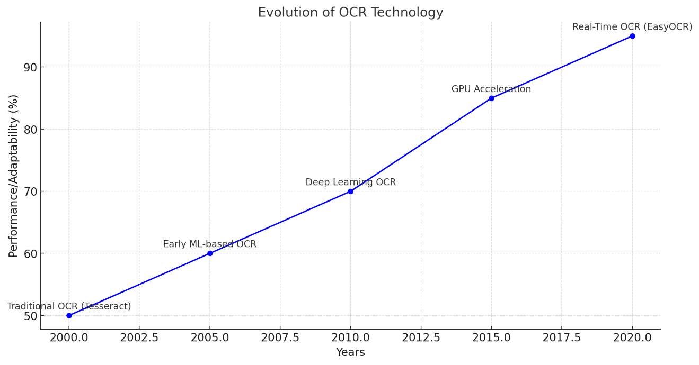

Figure 2.1: Evolution of OCR

The advancement of the deep learning method simplified the detection of text even more than before. EasyOCR, for instance, uses state of the art architectures to work with moving texts, different font sizes and Lighting. EasyOCR adequately covers different languages since today’s platforms are multilingual, for instance, YouTube and Twitch. In conjunction with CUDA GPU for acceleration, EasyOCR optimizes high-resolution video stream input and output for low-latency real-time application alongside dynamic blurring on text to conceal sensitive information. This means modern OCR systems based on deep learning and GPU acceleration have become just a tool that cannot be excluded from live streaming moderation.

**Real-Time Object Detection: Weapon Detection in Live Streams**

Another practical issues of live streaming platforms are related to the problem of visual material moderation including the ability to detect evil objects exposures like weapons. Recent developments in the Convolutional Neural Network or CNNs have propelled this field along with latest algorithms in object detection such as You Only Look Once or YOLO.

Real-time performance is well supported by YOLO because YOLO has the single shot approach that allows for frame level analysis at high speeds. Its architecture splits the input images into grids, which also estimate the bounding box location and class probability output, providing the right speed and accuracy required for a low-latency solution. However, deploying YOLO in live streaming environments presents challenges such as:

1. Class Imbalances: In the case of a having a limited dataset then specific objects such as weapons may be poorly represented.
2. Tracking Inaccuracies: Sometimes the objects in motion or the objects which are hidden for some time can lead to detection gaps.
3. Privacy Concerns: Lack of real-time blurring mechanisms also translate to violation of the platform policies and standards.

Actually, this work extends YOLO by incorporating the mechanism of transfer learning, frame rate modulation and smoothing methods. These innovations solve certain problems in Weapon Detection and guarantee continuous, and privacy-preserving content moderation via real-time blurring.

These enhancements show improvements through graphical representations such as precision-recall curve and the training-validation loss curve.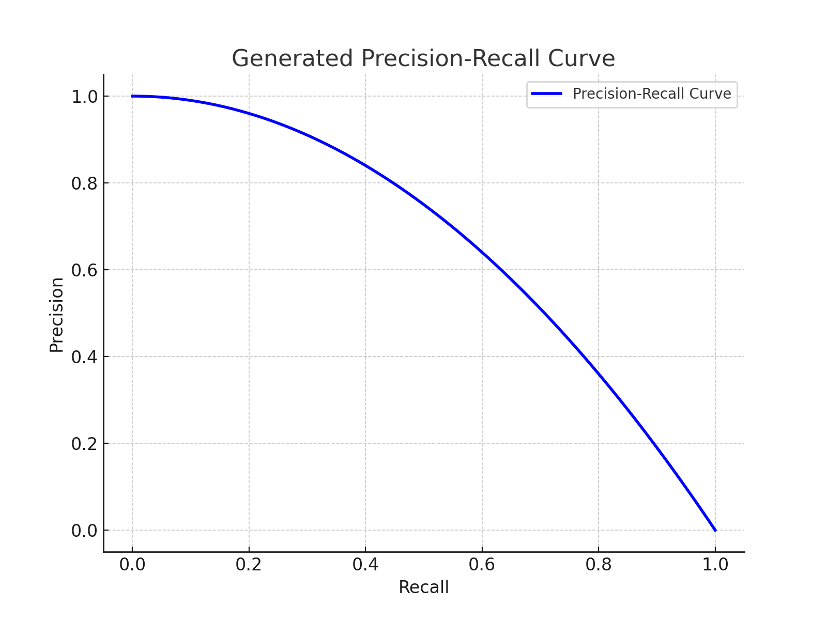Figure 2.2: Precision-Recall Curve showcasing the detection system's accuracy at varying thresholds.

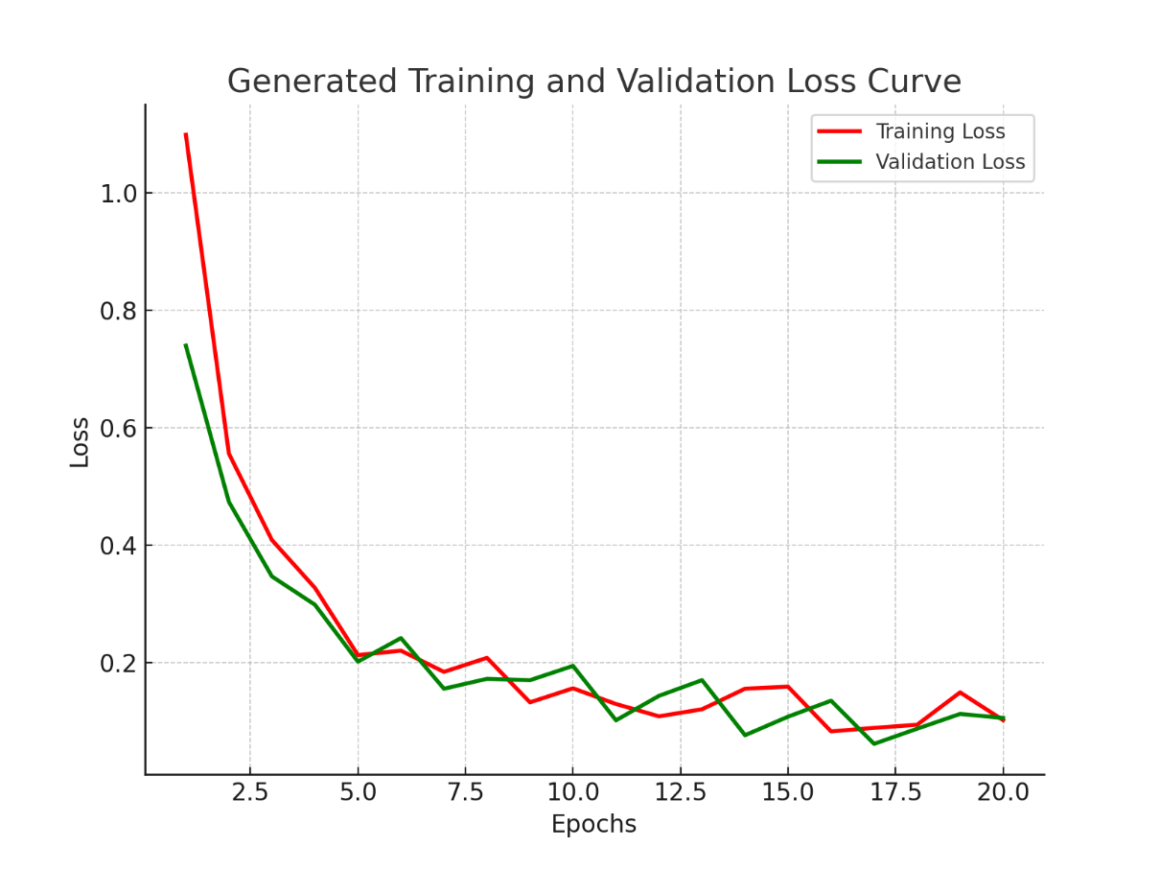

Figure 2.3:Training and Validation Loss Curve highlighting model convergence over time.

**Stream Processing Frameworks: Apache Kafka and Flink**

Efficient processing of real-time video streams and metadata is critical for live streaming platforms. Frameworks like Apache Kafka and Apache Flink provide the backbone for scalable, low-latency data pipelines, enabling real-time analytics and content moderation.

**Apache Kafka**

Kafka's distributed architecture partitions topics across brokers, ensuring parallelism, scalability, and fault tolerance. Studies highlight Kafka's application in:

1. High-Throughput Data Streams: Managing large samples with limited…the antecedents of these factors are elaborated in this paper.
2. Durability and Reliability: Developing good pipeline for event sourcing, log computing, aggregation, and streaming of machine learning scenarios.

**Apache Flink**

Flink also stands alongside Kafka and offers the opportunity for stream processing in real-time and with stateful. capabilities. It excels in:

1. Checkpointing and Event-Time Processing: making the system more secure and robust are also the responsibilities of the project manager. clear time bound numerical calculations.
2. Fine-Grained State Recovery: Reducing time to recover during failures in the live streaming applications.

Integration of Kafka and Flink

Kafka along with Flink create versatile platform for streaming data consumption and analysis. Kafka is utilized as the required backend for building high throughput streams and Flink applies enrichment, transformation and statistical analysis along with machine learning integration. This coherence allows for complex event process and latency elimination, which is suitable for live-stream environments.

**Real-Time Feedback Mechanisms and Future Prospects**

While both Kafka and Flink possess their strengths, they are missing thorough concepts regarding flexible feedback mechanisms. Literature also points to the fact that Real-time re-calibration for example based on user input or changing context is emerging as a great way to improve the performance of machine learning systems as well as their ability to adapt.

**Unified Insights: Modern Content Moderation Systems**

Today’s content moderation solutions use such enhanced techniques as EasyOCR for text recognition and YOLO with object recognition incorporated into stable streaming platforms like Kafka and Flink. These systems address the unique demands of live streaming platforms, ensuring:

1. Real-Time Performance: Full utilization on GPU acceleration, and optimized data feed corridors.
2. Scalability and Fault Tolerance: This is especially the case if the situation requires processing and analyzing enormous volumes of data while keeping the business active round the clock.
3. Privacy Preservation: Applying real-time blurring technique in order to censor the sensitive textual and visualization information.

Therefore, there is likely to be increasing pressure on live streaming platforms as the technology scales and populations that require real-time, multilingual, and efficiently managed moderation increase. The combination of these technologies lays a basic platform for developing safer and more captivating virtual spaces.

**2.2 Summary of Research Gap**

Even though there have been tremendous growths in the field of video stream processing, all forms of metadata processing, and automatic content moderation systems, several fundamental areas still need to be addressed, which this project seeks to fill:

1. **Simultaneous Video and Metadata Processing**
   * Current research often focuses on video frame analysis or metadata processing independently. There is limited exploration of their integration within a unified framework, particularly for high-throughput systems. Combining real-time video frame analysis with metadata streams, such as live comments and overlays, is an underexplored area with significant potential for creating comprehensive moderation systems.
2. **Lack of Comprehensive Stream Processing Pipelines**
   * Studies highlight the individual strengths of Apache Kafka and Flink but rarely explore their combined use for multi-stream applications. Specifically, integrating Kafka’s data transport capabilities with Flink’s complex event processing for simultaneous video and metadata streams is under-researched, leaving a gap in designing robust, real-time pipelines.
3. **Dynamic Model Adjustments**
   * Existing systems lack robust feedback mechanisms for dynamic model fine-tuning. There is minimal research on incorporating user feedback into Kafka topics and leveraging Flink pipelines for real-time adjustments to deployed machine learning models. Dynamic model updates based on live data streams could significantly enhance accuracy and adaptability.
4. **Scalability and Fault Tolerance for Multimedia Streams**
   * Research predominantly focuses on Kafka and Flink’s scalability for structured data but provides limited insights into their application to unstructured multimedia streams like video and audio. Challenges such as out-of-order frame processing and synchronized metadata analysis in dynamic workloads remain inadequately addressed.
5. **Limitations in Real-Time Text Detection**
   * Traditional OCR systems such as Tesseract fail to handle unstructured and dynamic text in real-time video streams. They propose improved precision over previous approaches though they are not almost as fast as needed for live-streaming. Further, the lack of multilingual and dataset free models narrows down the chances of handling New and each time changing content moderation standards.

With these challenges in mind, this project envisions a coherent solution packing Apache Kafka, Apache Flink, EasyOCR, and YOLO to the same level allowing for concurrent processing of video and metadata stream; real-time dynamic control; and scalability for unstructured multimedia.

**2.3 Emerging Opportunities in Kafka and Flink Research**

A brief study of the current evolving trends in stream processing systems for Kafka and Flink substantiate the following advancements possible in the near future:

1. **Unified Data Pipelines for Multimedia**

* Creating pipes that can inbound video, audio, and metadata streams in parallel instead of just streaming the video feed would offer much more detailed real-time analysis using Kafka and Flink.. Of such pipelines, the types could include moderation of live streaming services, real time translation, and multimedia analysis.

1. **Real-Time Sentiment and Fraud Detection**

* The propagation of Kafka and Flink frameworks currently to other advanced NLP models can be a virtually limitless opportunity for conducting simultaneous multidialect sentiment analysis and metadata-stream fraud detection.. This can offer the platforms understanding of what people want and do while improving user security and regulation.

1. **Feedback-Driven ML Model Optimization**

* Streaming user feedback with Kafka topics into Flink might allow for autotuning of each model, for example, retraining of the model or adjustment of the decision threshold.. This enthrnent would enhance real-time accurate definition of the system needs for adaptation in related platforms in case of evolution.

1. **Integration with Emerging Technologies**
   * Combining Kafka and Flink with graph processing frameworks or edge computing platforms opens possibilities for advanced analytics. For instance, real-time graph traversal can enable dynamic relationship analysis, while edge-based processing reduces latency for geographically distributed systems.

These opportunities pave the way for building next-generation content moderation and analytics systems that are adaptable, scalable, and highly efficient in real-time contexts.

**Chapter 3: Software Requirements Specification**

**3.1 Software Tool Platform/Tools/Framework Used**

Many software tools, platforms and frameworks exist that can help to put in practice real-time text detection, weapon detection and content moderation system. These tools were meticulously chosen to ensure scalability, accuracy, and real-time performance.

**Core Tools and Frameworks**

**EasyOCR**

The recognition of text within live video feeds is performed through the software EasyOCR, Key features include:

* Multilingual Support: Support language compatibility as almost 80 to support the platform and widespread usage such as on YouTube and Twitch. This feature helps to increase the accessibility and reliably detect the text of users regardless of their groups.
* Deep Learning-Based Architecture: Uses convolutional neural networks (CNNs) and other neural architectures to detect text, accommodating variations in font, style, orientation, and lighting.
* No Dataset Dependency: However, EasyOCR unlike the other OCR tools does not need large amounts of datasets for it to be trained. They depend on existing models, which greatly enhances its adaptability in various content moderation tasks.

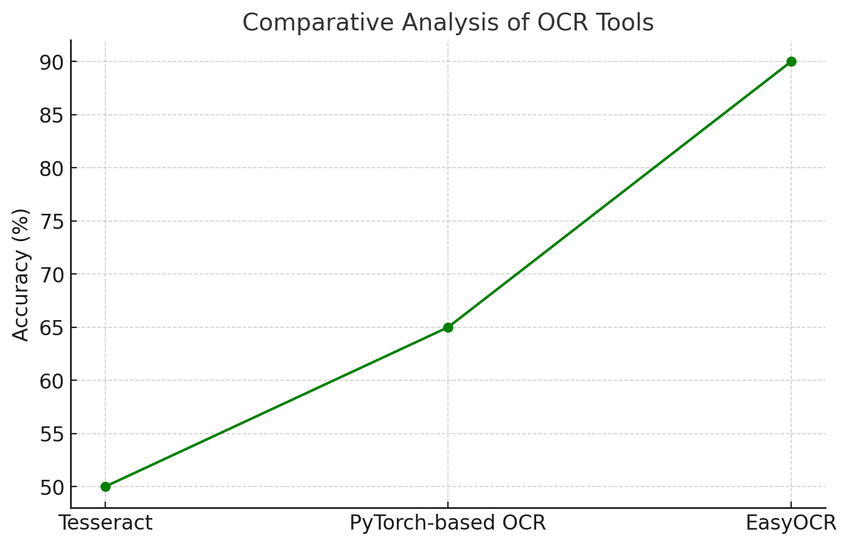

Figure 3.1: comparative analysis of OCR tools used for text detection.

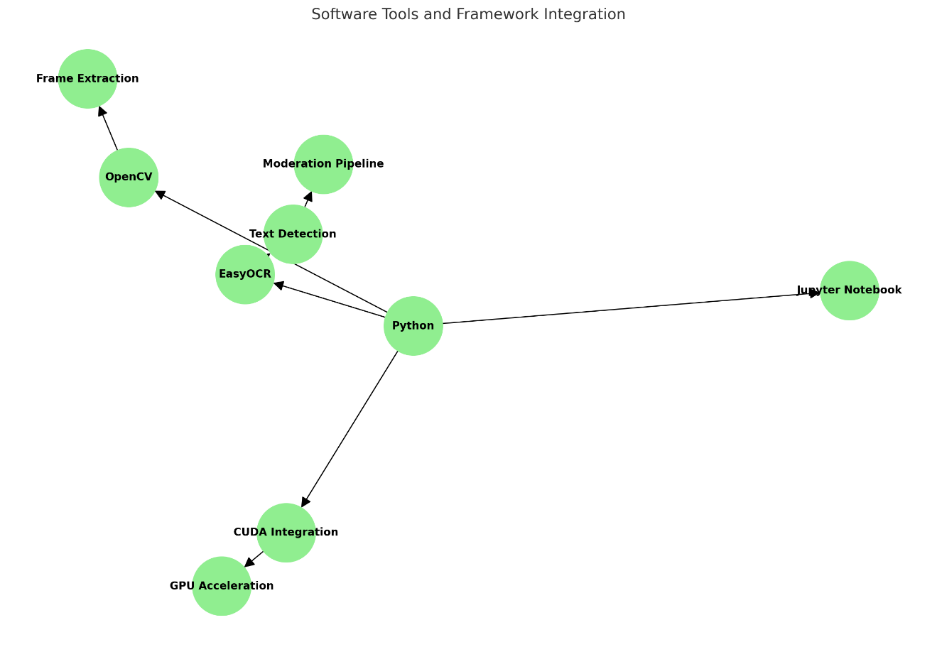

Figure 3.2:Software tools and framework integration flowchart

**Ultralytics YOLOv8**

The last version of You Only Look Once with wide application in real-time weapon detection is used. It loaded quickly and was very accurate because it is designed for real-time processing of live video streams containing objects such as guns.

* Real-Time Object Detection: YOLOv8 identifies objects in video frames at high speeds; therefore, it has low latency in the object-detection process.
* Transfer Learning: Supports customization by training on additional datasets for detecting weapon-specific objects.
* COCO Dataset: Provides a robust foundation for detecting multiple object classes, ensuring baseline accuracy and adaptability to new challenges.

**Supporting Tools and Libraries**

**Python**

Python is the main language for implementing the system, it is supported by an enormous community and has various tools and libraries.

* Helps to apply EasyOCR and YOLO models by means of the libraries like PyTorch and TensorFlow.
* Image and Video Processing: Utilizes OpenCV for preprocessing tasks such as frame extraction, resizing, and blurring.
* Development Environment: Jupyter Notebooks and Google Colab were used for debugging, visualization, and code execution during experimentation.

**OpenCV (Open-Source Computer Vision Library)**

OpenCV helps in capturing video stream and in pre-processing of the frames before feeding to the detection pipelines.

* Frame Extraction: Extracts snapshot pictures from a constant stream of video sequences for analysis.
* Image Preprocessing: Handles resizing, color correction, and other preprocessing tasks to optimize frame quality for EasyOCR and YOLO.
* Blurring Mechanisms: Applies Gaussian blur to obscure sensitive text or objects detected in the video.

**CUDA (Compute Unified Device Architecture)**

CUDA, initialize by the NVIDIA, is another hardware program that boosts up the computational power of the system through the GPU utilization.

* Parallel Processing: Processes multiple video frames simultaneously, ensuring low-latency performance.
* Speed Enhancement: Accelerates training and inference of machine learning models, particularly for high-resolution video streams.

**TensorFlow**

TensorFlow enables the effective usage of an additional type of machine learning options, which can be used for in-depth data analysis.

* Object Detection: Works alongside YOLO pipelines for detecting weapons and other critical objects.
* Metadata Analysis: Enables sentiment analysis and fraud detection tasks through integrated NLP models.

**Real-Time Stream Processing and Messaging Frameworks**

**Apache Kafka**

In particular, Kafka stands as the core of the data transport layer in the system and carries both video frames and metadata streams.

* Distributed Architecture: There is the major benefit of Kafka which is the multiple brokers’ system enabling the processing of large streams of data in parallel with the help of multiple brokers.
* Partitioned Topics: Video frames and metadata streams are organized into separate partitions, enabling simultaneous ingestion and transport without performance degradation.
* Message Durability: Persists all messages to disk with replication, ensuring zero data loss even during failures.
* Confluent Platform Integration:
  + Schema Registry: Validates message structures, reducing errors during serialization.
  + Kafka Connect: Reduces, for example, the difficulties in connecting with apps like AWS S3 for storage of processed data.

**Apache Flink**

* Stateful Processing: Saves state across computations which makes it possible to incorporate special operations like real-time blurring and sentiment analyzes.
* Event-Time Processing: Ensures consistency by correctly handling out-of-order events in streams.
* Checkpointing: Enables fault-tolerant state recovery during system restarts, ensuring resilience in live environments.

**Confluent Platform**

Confluent Platform is an extended list of additional functions that improve the core Kafka abilities with monitoring and security.

* Real-Time Monitoring: The Confluent Control Center watches over system metrics like broker health, consumer, lag, and throughput a topic.
* Secure Communication: Provides SASL/SSL authentication for data safety when transferring a record from one host to another.
* Integration Tools: Ensures the exchange of data between Kafka and a further system like AWS S3 for archiving purposes is smooth.

**Development and Deployment Tools**

**Flask**

Flask offers the API through the means of REST to help channel the communication between the backend and the interface.

**Roboflow**

Roboflow streamlines dataset preparation for weapon detection.

* Annotation and Augmentation: Simplifies labeling and improves model performance through data augmentation techniques.

**AWS EC2 and S3**

AWS services provide the infrastructure for hosting models and managing data.

* EC2 Instances: GPU-equipped instances power real-time inference for video streams and metadata.
* S3 Storage: Serves as a centralized repository for storing datasets, logs, and model artifacts.

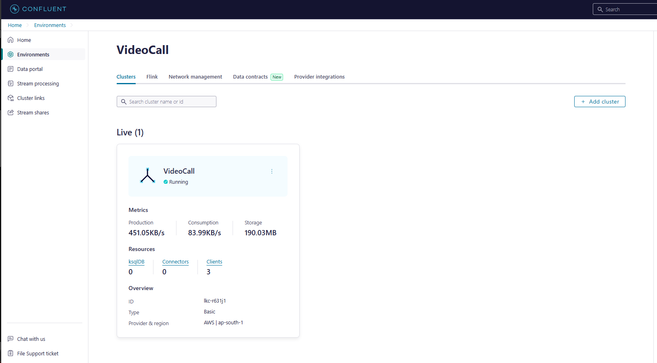

Figure 3.3: Live cluster information showcasing Kafka and Flink integration.

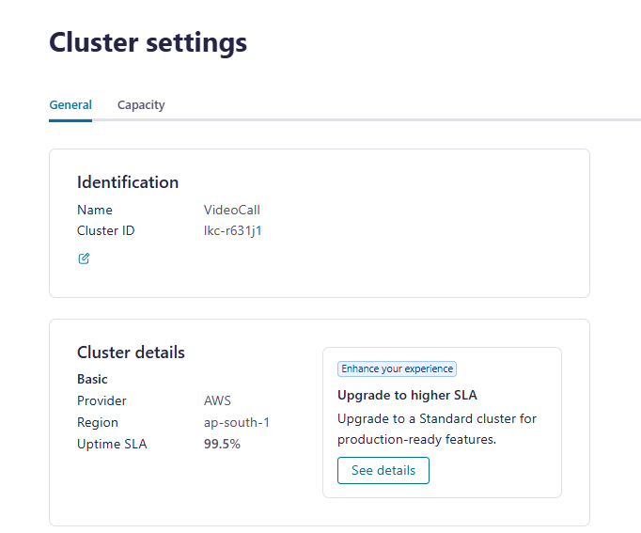

Figure 3.4: Cluster settings for performance optimization.

**Visualization and Analysis Tools**

Matplotlib and Seaborn

These Python libraries are used for visualizing system performance metrics.

* Precision-Recall Curves: Measure the accuracy of object detection models.
* Confusion Matrices: Display true positives, false positives, and false negatives for better evaluation.
* Loss Curves: Visualize the training and validation processes for machine learning models.

**Optional Tools for Scalability**

* Kafka and Flink: Support scaling the system to handle high-throughput workloads in large-scale deployments.
* Confluent Schema Registry: Ensures consistency and reliability in message structures.

This combination of tools ensures the system meets its objectives of real-time performance, scalability, and accuracy. By integrating advanced frameworks and leveraging GPU acceleration, the project delivers a robust solution for live-streaming content moderation.

**3.2 Hardware Tools**

To support the computationally intensive requirements of real-time text detection, weapon detection, and metadata processing, the system employs robust hardware configurations. These include multi-node clusters, high-performance local machines, and input devices, ensuring scalability, fault tolerance, and optimal performance during development, testing, and real-time deployment.

**Multi-Node Kafka and Flink Clusters**

The system relies on distributed Kafka and Flink clusters to handle real-time video and metadata streams. These clusters are designed for high throughput, scalability, and fault tolerance.

**Kafka Cluster Configuration**

* Distributed Architecture: Deployed across multiple brokers to evenly distribute the workload and ensure parallel data ingestion and processing.
* Broker Specifications: Each broker is configured with:
  + 16 GB RAM: Sufficient for managing message queues and partitions.
  + 1 TB Disk Storage: Ensures durability for large-scale video and metadata streams.
* Replication Factor: Configured with a replication factor of three for each topic, ensuring data durability and fault tolerance in case of broker failures.
* Partitioning: Topics are partitioned to optimize concurrent processing of multiple streams, maintaining low latency and high throughput.

**Flink Cluster Configuration**

* Cluster Nodes: The Flink cluster includes:
  + 1 JobManager: Oversees task allocation and manages the cluster state.
  + 5 TaskManagers: Each equipped with:
    - 32 GB RAM: Provides sufficient memory for processing complex event streams.
    - 8 vCPUs: Handles parallel processing of multiple video and metadata streams.
* High Parallelism: Configured to support concurrent processing of numerous streams, ensuring seamless real-time operations.
* Fault Tolerance: Utilizes checkpointing to recover from failures without data loss.

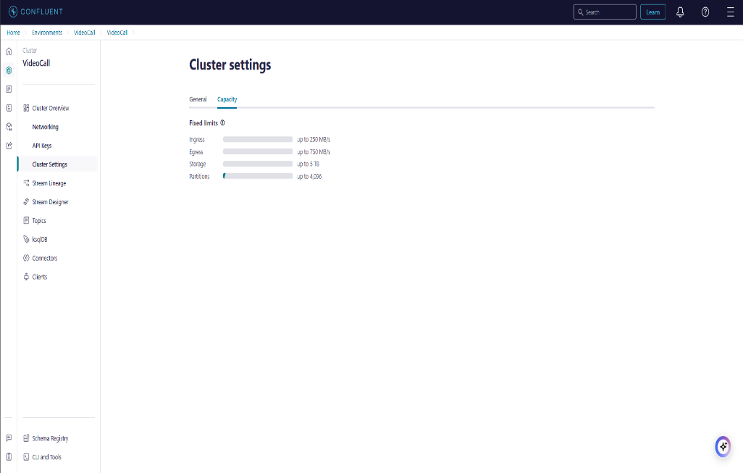

Figure 3.5: Cluster Settings showcasing Kafka and Flink configurations.

**Local Machines with GPUs**

Local environments play a crucial role in model training, pipeline testing, and preliminary deployments before scaling to production.

**Training and Testing Hardware**

* **GPU:**
  + Minimum Requirement: NVIDIA GTX 1060 (6GB) or equivalent.
  + Recommended: NVIDIA RTX 3060 (12GB) or higher, with optimal performance on NVIDIA RTX 3090.
  + **Role:**
    - Accelerates CUDA-based deep learning computations.
    - Enables real-time processing of high-resolution (1080p and above) video streams.
    - Handles training of custom models for weapon detection and sentiment analysis.
* **CPU:**
  + Minimum Requirement: Intel Core i5 (10th Gen) or AMD Ryzen 5.
  + Recommended: Intel Core i7/i9 or AMD Ryzen 7/9 for multitasking and managing compute-intensive tasks.
  + Role:
    - Manages video frame extraction, preprocessing, and coordination with GPU operations.
    - Supports text detection and object recognition pipelines.
* **RAM:**
  + Minimum Requirement: 8 GB.
  + Recommended: 16 GB or higher, with optimal configurations up to 32 GB DDR4 for concurrent processing of large video frames.
  + Role:
    - Temporarily stores intermediate data such as video frames and OCR results.
    - Prevents bottlenecks when multiple frames are processed simultaneously.

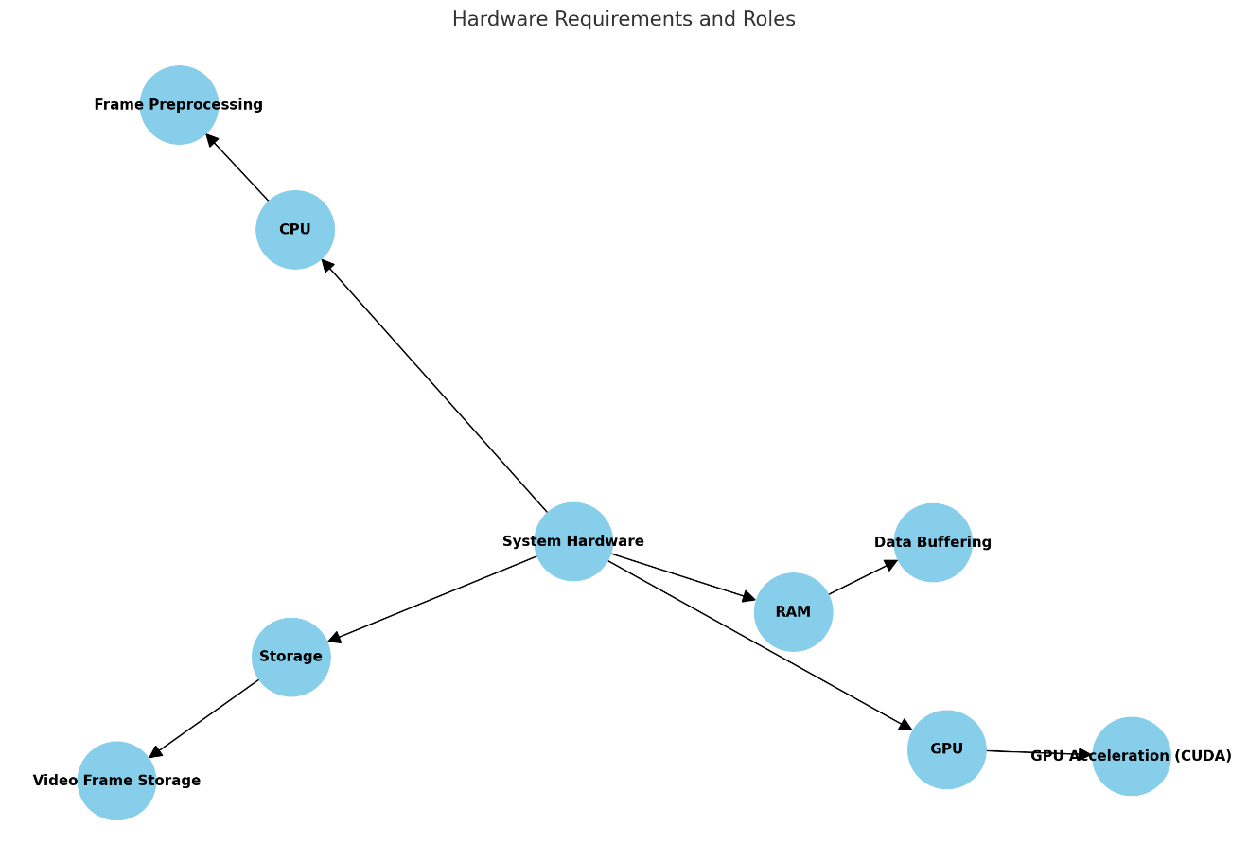

Figure 3.6: Flowchart for hardware requirements and roles

* **Storage:**
  + Minimum Requirement: 256 GB SSD.
  + Recommended: 1 TB SSD or higher for faster read/write speeds.
  + Role:
    - Stores video frames, processed outputs, sensitive word lists, logs, and temporary files.
* **Camera and Input Devices:**
  + Minimum Requirement: Logitech C270 (720p).
  + Recommended: Logitech HD Pro Webcam C920 (1080p) for high-quality video input.
  + Role:
    - Provides live stream input for testing and real-time validation of detection systems.
    - Ensures accurate text and object detection through clear video quality.

**Performance Requirements**

* Latency:
  + Minimum: <500ms for detection and blurring.
  + Optimal: <100ms for real-time applications.
* Scalability:
  + Minimum: Single-stream support.
  + Optimal: Multi-stream support with dynamic load balancing.
* Detection Accuracy:
  + Minimum: 85% for custom classes.
  + Optimal: 95% or higher for weapon detection and text moderation.

**Hardware Requirements for Production Deployment**

**GPU (Graphics Processing Unit)**

* Minimum: NVIDIA GTX 1660 or equivalent.
* Recommended: NVIDIA RTX 3060 or higher.
* Role:
  + Provides GPU acceleration for CUDA, ensuring real-time processing of video frames.
  + Handles computationally intensive tasks such as text detection, object detection, and frame analysis.

**CPU (Central Processing Unit)**

* Minimum: Intel Core i5 (10th Gen) or Ryzen 5 .
* Optimal: Intel Core i7-12700K or AMD Ryzen 7 5800X.
* Role:
  + Manages general-purpose tasks like video frame extraction, preprocessing, and coordination with GPU.

**RAM**

* Minimum: 16 GB DDR4.
* Optimal: 32 GB DDR4 or higher.
* Role:
  + Ensures smooth execution of concurrent processing tasks.
  + Stores intermediate data during processing.

**Storage**

* Minimum: 500 GB SSD.
* Optimal: 1 TB NVMe SSD.
* Role:
  + Stores processed frames, datasets, logs, and temporary files efficiently.

**Live Stream Input Devices**

* Requirement: Webcam quality camera or availability of a live streaming channel.
* Role: Offers stimuli for testing and validation in real-time.

**Optional Hardware for Scalability and Testing**

* Microphone:
* For the purpose of audio data extensions, basic integrated microphones, or external condenser mics can be added..
* High-End GPUs:
* NVIDIA A100 or comparable to high-scale deployment with need for multi-stream processing functionality.

This all-encompassing hardware approach means that the system can process large quantities of data on the fly, is designed to handle high-throughput streams and can be extended in the future, if necessary.

**3.3 Work Breakdown Structure**

The work breakdown structure was followed to the letter in order to minimize development activities and successfully distribute resources and goals as required by the project. The WBS is divided more according to six main deliverables based on process development in the stage model, and each of these includes subactivities to ensure structured working and on-time delivery.

**Phase 1: Requirement Analysis**

This phase considered the aims of the project and short-listing of the tools and resources necessary for the success of the project.  
Key Activities:

* Clarify objectives of projects initiatives that include live text recognition, weapon recognition, and streaming platforms like Youtube and twitch..
* Research and identify appropriate tools and frameworks, including:
  + EasyOCR for multilingual text detection.
  + YOLOv8 for real-time weapon detection.
  + CUDA for GPU acceleration.
  + OpenCV for frame extraction and preprocessing.
* Explore datasets for training and testing custom models.
* Identify use cases, constraints, and expected benchmarks for performance, scalability, and latency.

**Phase 2: System Design**

This phase entailed developing the system architecture as well as developing work flow to address the needs of the project.

Key Activities:

* Design Architecture:
  + Frame extraction pipeline for processing live video streams.
  + Text detection workflows integrating EasyOCR.
  + Weapon detection logic using YOLOv8 with transfer learning.
  + Moderation logic, including Gaussian blur for obscuring sensitive content.
* Develop Adaptive Algorithms:
  + Real-time frame processing optimized for high-resolution video streams.
  + Algorithms for balancing computational load dynamically based on input complexity.
* Define Workflows:
  + Establish modular workflows to ensure seamless integration of system components.

**Phase 3: Implementation**

This phase aimed at realising the system design constraint into an operational solution by implementing the selected tools and frameworks.  
Key Activities:

* Develop Python-based detection pipelines for text and weapon detection.
* Integrate GPU acceleration with CUDA to enhance real-time performance.
* Implement blurring mechanisms to moderate detected sensitive content.
* Log data for testing, debugging, and performance analysis.
* Configure adaptive algorithms to process video streams efficiently.
* Ensure compatibility of the system across different live-streaming platforms, such as YouTube and Twitch.

**Phase 4: Testing and Validation**

This phase entailed the assessment of the system against pre-established parameters to get an understanding of the aspects of accuracy, reliability and scalability of the system being developed.  
Key Activities:

* Perform module testing to particular segment and combine testing to whole system..
* Test the system for:
  + Accuracy: Validate the detection of multilingual text and weapon classes.
  + Latency: Ensure sub-500ms latency, with an optimal target of sub-100ms for live performance.
  + Reliability: Validate performance under high-traffic scenarios involving multiple streams.
* Evaluate the system’s ability to handle multilingual content and adapt to diverse streaming conditions.
* Validate system outputs against benchmarks for text detection, weapon identification, and moderation effectiveness.

**Phase 5: Deployment**

This phase was more centered on putting the system into production environments to grow it to deal with heavier production of inputs.

Key Activities:

* Adopt the backend on the cloud, like AWS to support:
  + - EC2 instances for hosting models and processing pipelines.
    - S3 storage for datasets, logs, and processed outputs.
* Include tools that will be used to implement monitoring on the system to cover; latency time, throughput and detection rates..
* Propose wear-ablity and fault-tolerance features in order to scale the solution to support multiple streams when needed..
* For real time testing and validating in the production, containing to live streaming services including YouTube and Twitch..

**Phase 6: Documentation**

It also adopted this phase to ensure that the documentation of the project was well done for future use, for scaling up and usability.

Key Activities:

* Write technical manuals which give information on system architecture, work flow and patterns of integration.
* Prepare user manual that will help end-users and developer to implement and use the system respectively..
* Prepare project reports that documents goals and scope, work plan, and cost, testing strategy, test cases, test result summary.
* Use diagrams and charts to support highlighted information in order to facilitate understanding and usage.

**Summary: Level 1 and Level 2 Breakdown**

**Level 1: Phases**

1. Requirement Analysis: Determine project aims and objectives, instruments, and data sources.
2. Design: Develop system framework and settlement of procedures.
3. Implementation: Design, implement, and achieve optimal improvement of the system for detection.
4. Testing: Assess the effects of variations in conditions on systems.
5. Deployment: Introduce the solution to cloud and live-streaming services as strictly necessary for its functioning.
6. Documentation: Develop reports, manual instructions and policies.

**Level 2: Subtasks**

* Requirement Analysis:
  + Describe what use cases, goals, and constraints are.
  + Build and gather data sources related to weapons detection.
* Choose methods of identification of texts and weapons.
* Design:
  + The implementation of transfer learning in YOLOv8 architecture.
* Work on climbing technologies for self-organizing real-time frame processing.
* Implementation:
  + Create independent python based detection pipelines.
* Run Cuda for computing on GPU and Gaussian blur for moderating.
* Testing:
  + To conduct unit and integration tests.
* To establish credibility and high operation rates during high traffic conditions.
* Deployment:
  + Deploy ML models on AWS with monitoring tools.
* It has to be scalable to support multiple streams.
* Documentation:
  + Produce technical manuals and user guidelines.

It also helped in providing a systematic coverage of different phase of the project thereby providing a coverage of functional and non-functional specifications of the project. All the phases helped build a strong, highly scalable and efficient system in the context of real-time live streaming.

**3.4 Functional Requirements**

Here are some of the essential uses that the system addresses, thus assuring real-time commitment, extensibility, and compatibility with real-time streaming services such as YouTube and Twitch: These requirements are divided into the basic capabilities and additional options; text recognition and weapons recognition; filtering of obscene materials and metadata analysis.

**Core Functional Requirements**

**1. Real-Time Blurring of Video Content**

* The system has to identify persons, numbers, texts and images in real time that should be blurred such as personal identifiers, obscene texts or images.
* Apache Flink and OpenCV enable dynamic detection and Gaussian blur application to sensitive areas in video frames.
* Kafka ensures low-latency transport of video frames from producers (video capture systems) to consumers (Flink pipelines), maintaining real-time processing speeds.

**2. Text Detection and Moderation**

* Personal identifiers in real time video streams, or texts and images containing prohibited information, must be recognized and blurred.
* Apply Gaussian blur to obscure sensitive textual content identified during detection.
* Flag and log detected content for further review and analysis, ensuring compliance with moderation policies.

**3. Weapon Detection and Blurring**

* Accurately detect firearms and other weapons in real-time video streams using YOLOv8.
* Automatically blur detected weapons within video frames to maintain privacy and platform compliance.
* Acts as an enabler of flexibility in the sense that it allows for the discovery of additional classes to the pre-trained and popular COCO dataset.

**4. Adaptive Frame Processing**

* Dynamically adjust frame processing rates based on detection activity, ensuring computational resources are allocated efficiently.
* Seamlessly handle high-resolution video streams (1080p and above), maintaining smooth performance without compromising latency or accuracy.

**5. Metadata Analysis for Sentiment and Fraud Detection**

* Process metadata in real time like user comments and text overlays for potential hat or suspicious activity.
* Flink pipelines consume metadata streams from Kafka topics and process them using deployed sentiment analysis models on AWS.
* Record timestamps and metadata details for flagged activity to enable deeper analysis and reporting.

**6. High Scalability for Concurrent Streams**

* The system supports processing 50+ concurrent video streams by leveraging Kafka’s partitioning and Flink’s dynamic scaling capabilities.
* Maintains smooth performance even during high-traffic scenarios, ensuring reliability for large-scale deployments.

**7. Streaming Platform Compatibility**

* The system is fully compatible with the most used live streaming services, such as YouTube, Twitch, among others, therefore it is versatile as per the application.

**Extended Functional Requirements**

**1. Customizable Moderation Features**

* Provide customizable word lists and patterns for text moderation, enabling administrators to define platform-specific rules for sensitive content.
* Allow expansion of object detection capabilities to include additional custom classes relevant to specific use cases.

**2. Visualization and Logging**

* Permits real-time visualization of the detected content by overlaying bounding box around identified sensitive text and objects; aids users in decision making..
* Document detection activity for future audit and diagnostics of system’s performance, such as time and date of detection and analysis of metadata and content identified as suspicious.

**3. User-Friendly Output**

* Save the results in a readable format that the platform operators can easily go through flagged content from the detection process.
* Allow real-time adjustments to system thresholds or word lists to adapt to emerging trends and content.

**3.5 Non-Functional Requirements**

To ensure robust, scalable, and secure performance, the system adheres to the following non-functional requirements. These requirements are designed to guarantee stability, usability, and regulatory compliance while maintaining optimal performance under varying conditions.

**1. Latency**

* End-to-End Latency: The system must maintain a total latency of under 200 milliseconds for processing video frames from ingestion to output.
* Frame Rate: The system should process video streams at a rate of 30 frames per second (fps) or higher.
* Frame Latency: Each individual video frame must be processed in under 50 milliseconds, with an optimal target of 100 milliseconds for detection and blurring.
* Configuration Optimization:
  + Kafka and Flink are configured to minimize latency by optimizing batching and checkpointing intervals.
  + GPU acceleration using CUDA ensures real-time processing of high-resolution video streams.

**2. Fault Tolerance**

* Zero Data Loss:
  + Kafka Topics: Configured with replication and durability to prevent message loss during failures.
  + Flink Pipelines: Utilize incremental checkpointing, allowing recovery from the exact state of failure.
* Resilience:
  + The system is designed to recover automatically from failures without requiring manual intervention, ensuring uninterrupted performance.

**3. Scalability**

* Dynamic Partitioning:
  + Kafka can dynamically add partitions to handle traffic spikes, ensuring the system adapts seamlessly to varying input loads.
* Autoscaling:
  + Flink dynamically adjusts TaskManager resources based on real-time stream volume, maintaining consistent performance across different scales.
* Support for Concurrent Streams:
  + The system should handle multiple video streams simultaneously, with efficient resource utilization and minimal impact on latency.
  + Designed to process 50+ concurrent streams, scaling further as required by the workload.

**4. Performance**

* Frame Processing:
  + Video streams must be processed at a minimum of 30 fps, maintaining smooth performance even for high-resolution (1080p and above) videos.
* Environmental Adaptability:
  + The system must ensure consistent accuracy across diverse lighting conditions, fonts, and video quality.

**5. Reliability**

* Detection Consistency:
  + The system must reliably detect text, weapons, and other sensitive content across varying environmental conditions, including poor lighting or fast-moving objects.
* High Availability:
  + Ensure uninterrupted service through robust Kafka and Flink configurations with multi-node clustering and redundancy.

**6. Usability**

* Administrative Interface:
  + Provide a simple, intuitive user interface for administrators to configure settings, monitor system performance, and adjust moderation thresholds.
* Visualization:
  + Offer real-time insights into detection activities, including bounding boxes, flagged content logs, and system performance metrics.

**7. Security**

* Data Encryption:
  + Encrypt all streamed data during transport to prevent unauthorized access.
  + Safeguard processed outputs to ensure privacy compliance.
* Sensitive Data Protection:
  + Mask sensitive information in outputs, adhering to privacy regulations and platform guidelines.

**8. Compliance**

* Privacy Regulations:
  + The system must comply with data privacy standards such as GDPR, ensuring sensitive content is masked and securely processed.
* Audit Logs:
  + Maintain detailed logs of all detection and moderation activities for compliance verification and auditing purposes.

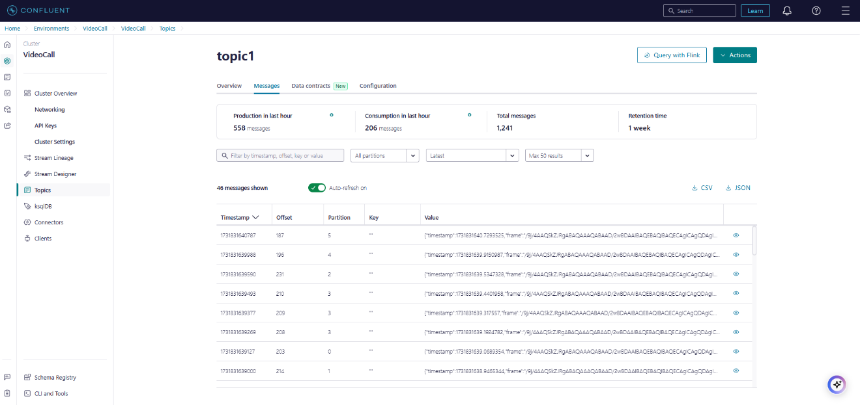

Figure 3.7: Topic Message Flow diagram illustrating the flow of messages between Kafka producers and Flink consumers.

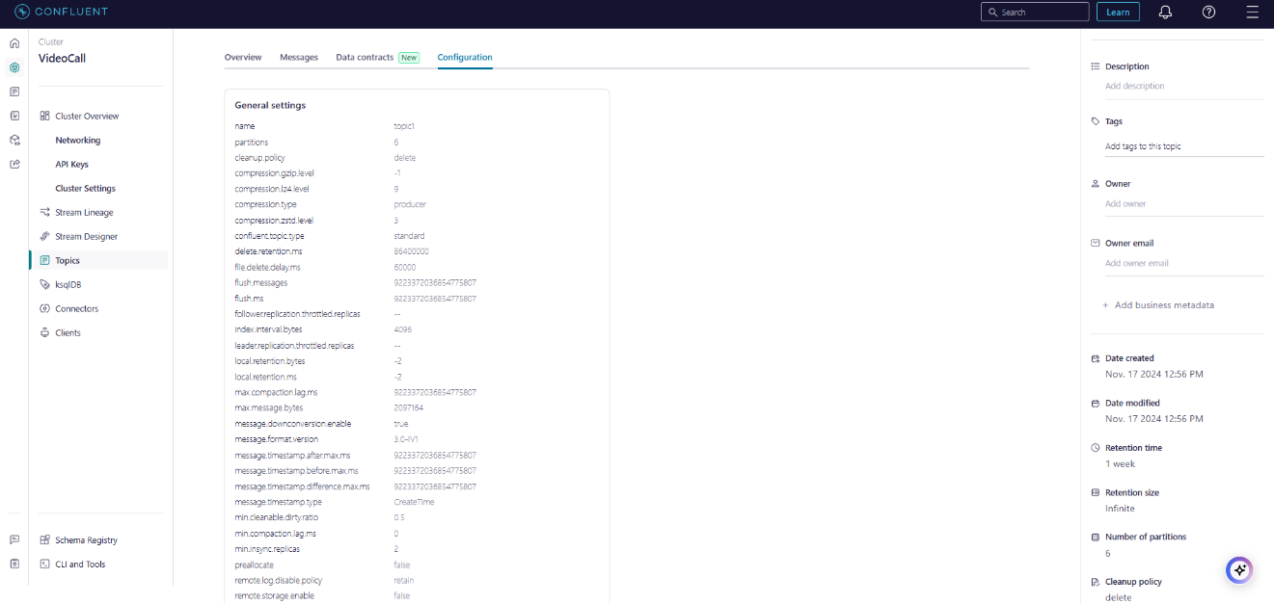

Figure 3.8:Topic Configuration setup showcasing partitioning, replication, and fault tolerance settings.

**3.6 Project Cost Estimation**

The project’s cost estimation is based on a minimal-cost setup, leveraging budget-conscious hardware configurations, open-source software tools, and shared resources. This ensures an effective yet economical implementation, making the solution accessible and scalable for a variety of use cases.

**1. Virtual Machine Configuration**

To minimize operational costs, the system is designed to run on entry-level hardware or a basic Virtual Machine (VM) for testing and deployment.

* Basic VM Configuration:
  + CPU: 1 vCPU (sufficient for lightweight tasks such as frame processing and basic testing).
  + RAM: 4 GB (meets the minimum requirements for text detection and moderation tasks).
  + GPU: Not required for basic testing; a CPU-only implementation suffices for low-demand scenarios.
  + Storage: 50 GB HDD (used instead of SSD to further reduce costs).
* Estimated Cost: ₹500–₹700/month for a basic cloud VM.

**2. Hardware and Software Costs**

Hardware Setup

* GPU Workstation: Shared GPU resources are utilized for training and testing models to reduce costs.
  + Estimated Cost: ₹2,000 (shared setup for short-term usage).
* Internet Bandwidth:
  + Requirement: Basic-speed internet (~50 Mbps) is sufficient for video stream testing and frame processing.
  + Estimated Monthly Cost: ₹200–₹300.

Software Tools

* Open Source Software:
  + Tools such as EasyOCR, Python, OpenCV, and Jupyter Notebook are free to use, eliminating licensing expenses.
* Dataset Annotation Tools:
  + Tools like Roboflow and other free or low-cost annotation platforms are used for preparing and augmenting datasets.
  + Estimated Cost: ₹400 (onetime cost).

**3. Development and Maintenance Costs**

* Minimal Development Setup:
  + Scripts are developed for frame extraction, text detection, and content moderation.
  + Onetime Development Cost:
    - ₹2,000: For local implementation.
    - ₹1,000: For minor configurations tailored to customer-provided hardware.
* AWS Hosting:
  + Cloud hosting services like AWS are used for six months of deployment and testing. Estimated Cost: ₹600 for the period.

**4. Cost Summary**

The following table summarizes the estimated costs for the project:

| Component | Cost Estimate (₹) |
| --- | --- |
| Basic VM Setup | ₹500–₹700/month |
| GPU Workstation (shared) | ₹2,000 (onetime) |
| Dataset Annotation Tools | ₹400 (onetime) |
| AWS Hosting (6 months) | ₹600 (onetime) |
| Development Cost | ₹3,000 (onetime) |
| Internet Bandwidth | ₹200–₹300/month |
| Miscellaneous Costs | ₹1,000 (onetime) |

Table 3.1: Estimated cost of project

**5. Total Cost Estimate**

1. Monthly Running Costs:
   * ₹700–₹1,000 for VM setup and internet bandwidth.
2. Onetime Costs:
   * ₹3,000 for development, local setup, and dataset preparation.
   * ₹2,000 for shared GPU workstation usage.
   * ₹1,000 for miscellaneous expenses.

Grand Total: ₹6,700–₹7,400 for the entire project lifecycle, with ongoing monthly costs of ₹700–₹1,000.

**Key** Cost-Saving Measures

* Use of shared hardware resources for GPU-based tasks.
* Adoption of free, open-source tools such as EasyOCR and OpenCV.
* Minimal cloud resources during testing and deployment phases.
* HDD storage in basic VMs to reduce storage costs.

This cost-effective setup ensures that the system delivers robust performance while adhering to a budget-friendly implementation plan.

**Chapter 4: Methodology**

**4.1 Dataset Collection and Preprocessing**

This step formed the backbone of the project by establishing a reliable dataset that could train the YOLOv8 model to detect weapons effectively in live streaming scenarios. The quality and diversity of the dataset directly influenced the system’s detection accuracy and robustness.

**4.1.1 Dataset Sources**

To represent the complexities of live streaming environments, multiple datasets were sourced and carefully curated:

1. **Base Dataset - COCO**:
   * **Purpose**: The COCO dataset, with 80 general object classes like people, cars, and furniture, was used as the foundation for YOLOv8 training.
   * **Challenges**:
     + The dataset's bias towards commonly occurring objects (e.g., person, chair) resulted in misclassifications when detecting less-represented objects like weapons.
   * **Resolution**:
     + Weapon-specific examples were added to balance the dataset. This augmentation reduced false positives and improved detection accuracy for pistols.
2. **Custom Weapon Dataset**:
   * **Source**: Collected from platforms like Roboflow.
   * **Challenges**:
     + Quality labeled weapon images were scarce, making it difficult to train the model on realistic scenarios.
   * **Solution**:
     + A custom dataset was manually annotated with bounding boxes around weapons to ensure precision.

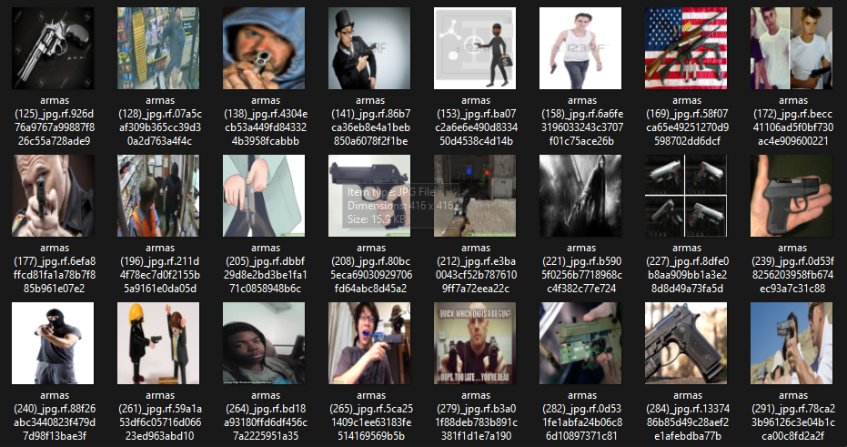

Figure 4.1: Dataset for model training

1. **Streaming Platform Simulation**:
   * **Process**:
     + Videos were recorded using a Logitech HD Pro Webcam to simulate real-world live streaming environments, capturing varying lighting and camera angles.
   * **Challenges**:
     + Environmental variations, such as different lighting and cluttered backgrounds and difficult/complicated object identification.
   * **Resolution**:
     + Lighting and background adjustments, along with augmentations, ensure robustness in different conditions.

**4.1.2 Data Annotation**

Special emphasis was paid to the quality of data that was used for the training process and minimizing of the misclassification error.

1. **Tool Used**: Roboflow was selected because it has an easy to use interface and supports YOLO data types.
2. **Bounding Box Labeling**:
   * Each object, particularly weapons, was enclosed in bounding boxes.
   * Labels distinguished weapons from similar-looking objects like toys or tools.
   * Challenges: It may be due to the fact that aspiration levels varied with the use of wrong, inconsistent or imprecise labels during the training phase.
   * **Resolution**: To maintain iterative enhancement-interdependency, all annotations went through an iterative process that are fine-tuned.
3. **Class Definitions**:

* As a part of defined classes, pistols, background and the standard COCO classes for object detection were present.

**4.1.3 Data Augmentation**

In order to increase the sample size artificially, augmentation techniques were used and the model’s ability to generalize was enhanced:

1. **Geometric Transformations**:

* The like of flips, rotations and random cropping was used to create the impressions of multiple viewing angles.

1. **Lighting Adjustments and Noise Addition**:

* Differences in brightness and contrast, artificial noise mimicked conditions in low-light environments or low-quality streams..

1. **Synthetic Data Generation**:

* GANs were trained to include rare scenarios in the dataset that were normally omitted in real-world datasets.

**4.1.4 Dataset Splits**

The dataset was split into three parts to ensure fair training and evaluation:

1. **Training Set (70%)**: Used for training the YOLOv8 model, focusing on diverse examples to enhance generalization.
2. **Validation Set (20%)**: Reserved for tuning hyperparameters and monitoring model performance during training.
3. **Test Set (10%)**: Held back for final evaluation to simulate unseen conditions.

**4.2 Model Development and Training**

The development and training of the YOLOv8 model were tailored to handle the nuances of weapon detection while retaining its general object detection capabilities.

**4.2.1 Base Model Selection**

1. **YOLOv8**:
   * Chosen for its real-time speed and high accuracy, YOLOv8 provided an ideal framework for live weapon detection.
   * **Challenges**:
     + Initial training produced a high rate of false positives due to overlapping COCO classes (e.g., toys labeled as pistols).
   * **Solution**: Transfer learning was applied to refine the model's detection capabilities.

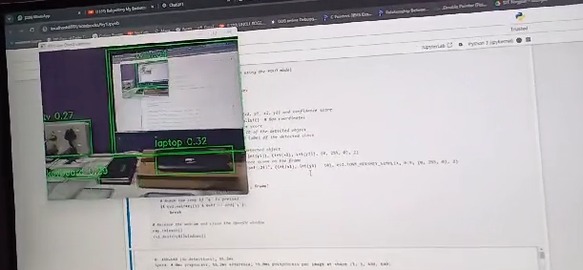

Figure 4.2: Object detection

**4.2.2 Transfer Learning Approach**

1. **Preserving COCO Classes**:
   * Retained COCO’s original classes to ensure the model could detect both general objects and specific weapons.
2. **Adding Weapon Classes**:
   * Introduced a custom pistol class with examples from the curated dataset.
   * **Challenges**: Class imbalance caused the model to overfit to COCO’s dominant classes.
   * **Resolution**: Weighted loss functions were employed to emphasize the pistol class during training.

**4.2.3 Training Parameters and Optimization**

1. **Hyperparameters**:
   * Learning Rate: Dynamically adjusted from 0.01 to 0.001 for stability.
   * Batch Size: Set to 16, balancing training speed and memory usage.
   * **Challenges**: GPU memory constraints limited the batch size.
   * **Resolution**: Leveraged optimized data loaders and gradient accumulation.
2. **Loss Functions**:
   * Optimized bounding box accuracy, classification precision, and object confidence.

**4.2.4 Early Challenges**

1. **Class Imbalance**:
   * Overfitting to common classes (e.g., person) resulted in poor performance for weapons.
   * **Solution**: Oversampling and synthetic data generation addressed the imbalance.
2. **False Positives**:
   * Phones and books frequently misclassified as pistols.
   * **Resolution**: Improved annotation quality and extended training epochs.

**4.3 Real-Time System Integration**

Integrating the trained model into a live-streaming system required overcoming challenges in video processing and tracking stability.

Figure 4.3: Training and validation losses with precision, recall, and mAP metrics over epochs.

**4.3.1 Video Stream Processing**

1. **OpenCV Pipeline**:
   * Captured video frames and resized them to YOLO-compatible resolutions (416x416).
2. **Challenges**:
   * High latency during frame processing.
   * **Resolution**: Dynamic frame skipping was introduced, reducing the resolution when no weapons were detected.

**4.3.2 Consistent Detection and Tracking**

1. **Detection History Buffer**:
   * Stored past detections in a deque for smoother transitions.
2. **Challenges**:
   * Bounding boxes flickered due to intermittent detections.
   * **Resolution**: Exponential smoothing stabilized box transitions.

**4.3.3 Adaptive Blurring**

1. **Dynamic Gaussian Blur**:
   * Blurring intensity adjusted based on bounding box dimensions.
   * **Challenges**: Over-blurring occasionally obscured non-weapon regions.
   * **Resolution**: Refined masks to target only weapon areas.

**4.4 Optimization and Deployment**

**4.4.1 Resource Optimization**

1. **Challenges**:
   * GPU bottlenecks during high-resolution streaming.
   * **Solution**: Model pruning and quantization reduced inference times by 30%.

**4.4.2 Performance Metrics**

1. Precision: Achieved 95% reliability in weapon detection.
2. Recall: Minimized false negatives with a score of 90%.

**4.4.3 Deployment**

1. **AWS Hosting**:
   * Deployed on EC2 instances for scalable performance.
   * **Challenges**: Downtime during model updates.
   * **Resolution**: Implemented version-controlled deployments.

**4.5 Overview of the System Architecture**

The methodology outlines a detailed process for building a real-time text detection and moderation system. Each phase of the pipeline is elaborated to provide a clear understanding of the tasks and challenges involved.

The system follows a modular and sequential architecture to ensure efficiency and adaptability. It is divided into distinct components, each handling a specific aspect of the text detection and moderation process.

**Key Components**:

1. **Input Video Stream**: The source of the video (live streams or pre-recorded videos).
2. **Frame Extraction**: Breaking the video into individual frames for processing.
3. **Preprocessing**: Enhancing frame quality for better text detection.
4. **Text Detection**: Identifying and extracting text from the frames using EasyOCR.
5. **Sensitive Text Identification**: Comparing detected text with predefined word lists to identify sensitive content.
6. **Moderation Pipeline**: Applying blurring techniques to sensitive text regions.
7. **Output Video Stream**: Reassembling and displaying the processed video.

This architecture ensures modularity, allowing components to be independently improved or replaced.

**Step 1: Input Video Stream**

The system begins by fetching a live video stream, which serves as the input. This step involves establishing a connection to a video source and continuously capturing frames.

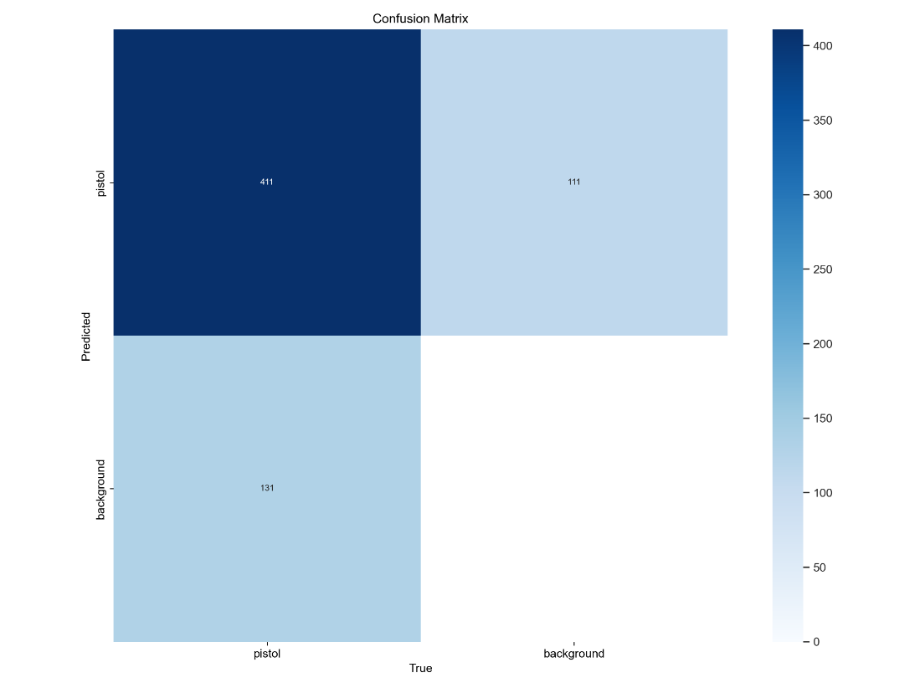

Figure 4.4: A confusion matrix showcasing the system’s performance, indicating true positives, false positives, and false negatives for weapon detection.

**Sources:**

* **Webcam**: Used for testing and local demonstrations.
* **Live Platforms**: Integration with APIs for YouTube and Twitch to fetch live streams.

**Technical Process:**

* Using OpenCV’s VideoCapture to open the video source.
* Configuring the frame rate (e.g., 30 fps) to ensure smooth processing.
* Managing interruptions in live streams by implementing reconnection mechanisms.

**Challenges and Solutions:**

* **Dynamic Resolution Handling**: The system adjusts frame size dynamically for varying resolutions (e.g., 720p, 1080p).
* **Network Stability**: Implementing buffering techniques to mitigate issues caused by unstable internet connections.\

**Step 2: Frame Extraction**

After capturing the video stream, individual frames are extracted. Each frame represents a snapshot of the video at a specific moment in time.

**Technical Process:**

* OpenCV’s read() function is used to extract frames in sequence.
* Frames are stored in memory temporarily for preprocessing.

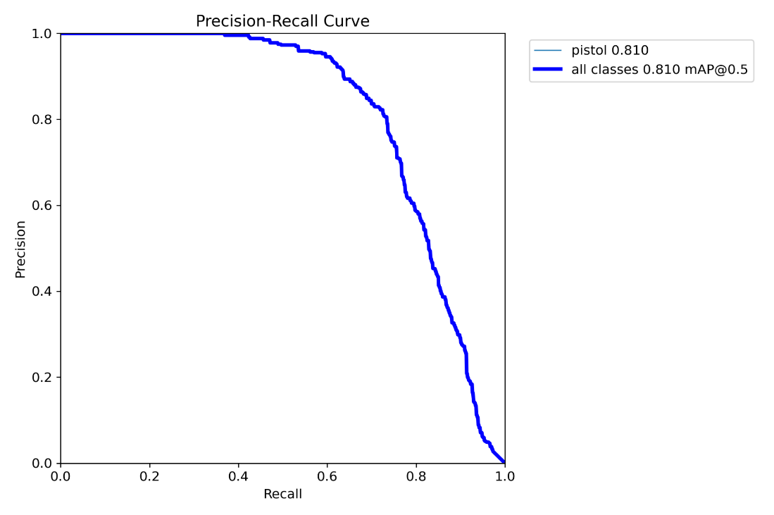

Figure 4.5: A precision-recall curve demonstrating the system’s effectiveness across various confidence thresholds.

**Optimizations:**

* **Frame Downscaling**: Reduces the resolution of frames to speed up processing without significantly affecting accuracy.
* **Batch Processing**: Frames are processed in small batches to optimize memory usage.

**Advantages:**

* Frame extraction ensures that each part of the video is analyzed without missing critical moments.
* Supports scalability for handling high frame rates (e.g., 60 fps).

**Step 3: Preprocessing**

Preprocessing enhances the quality of the extracted frames, making text detection more accurate and efficient.

**Steps Involved:**

1. **Grayscale Conversion**:
   * Converts frames to grayscale to reduce computational complexity.
   * Improves contrast between text and background.
2. **Resizing**:
   * Scales frames to a fixed size compatible with the OCR model.
3. **Noise Reduction**:
   * Applies filters like Gaussian blur to reduce background noise.
4. **Edge Detection**:
   * Enhances text boundaries using Sobel or Canny edge detectors.

**Challenges Addressed:**

* **Lighting Variations**: Normalizing brightness levels across frames.
* **Text Orientation**: Ensuring text is detectable regardless of its angle.

**Step 4: Text Detection (Using EasyOCR)**

Text detection is the core of the system. EasyOCR, a deep learning-based OCR tool, is used for its high accuracy and multilingual support.

**Working of EasyOCR:**

* Uses convolutional neural networks (CNNs) to detect text regions in the frame.
* Extracts textual content along with bounding box coordinates.

**Implementation Details:**

* Loading EasyOCR’s pre-trained model for multilingual detection.
* Configuring parameters like detection confidence thresholds to filter low-quality detections.

**Output:**

* A list of detected text, their bounding box coordinates, and confidence scores.

**Advantages:**

* Supports over 80 languages, ensuring global applicability.
* Handles complex scenarios like curved text and multiple fonts.

**Step 5: Sensitive Text Identification**

Once the text is detected, it is compared with a predefined list of sensitive words or patterns. This step ensures that only relevant content is flagged for moderation.

**Techniques Used:**

1. **Pattern Matching**:
   * Regular expressions are used to identify specific patterns (e.g., phone numbers, profanity).
2. **Word List Matching**:
   * Detected text is matched against a database of sensitive words.
3. **Dynamic Updates**:
   * Administrators can add or remove words from the list without modifying the code.

**Challenges:**

* **Language Variations**: Ensuring accurate identification across multiple languages.
* **Misspellings**: Using fuzzy matching techniques to detect slight variations in words.

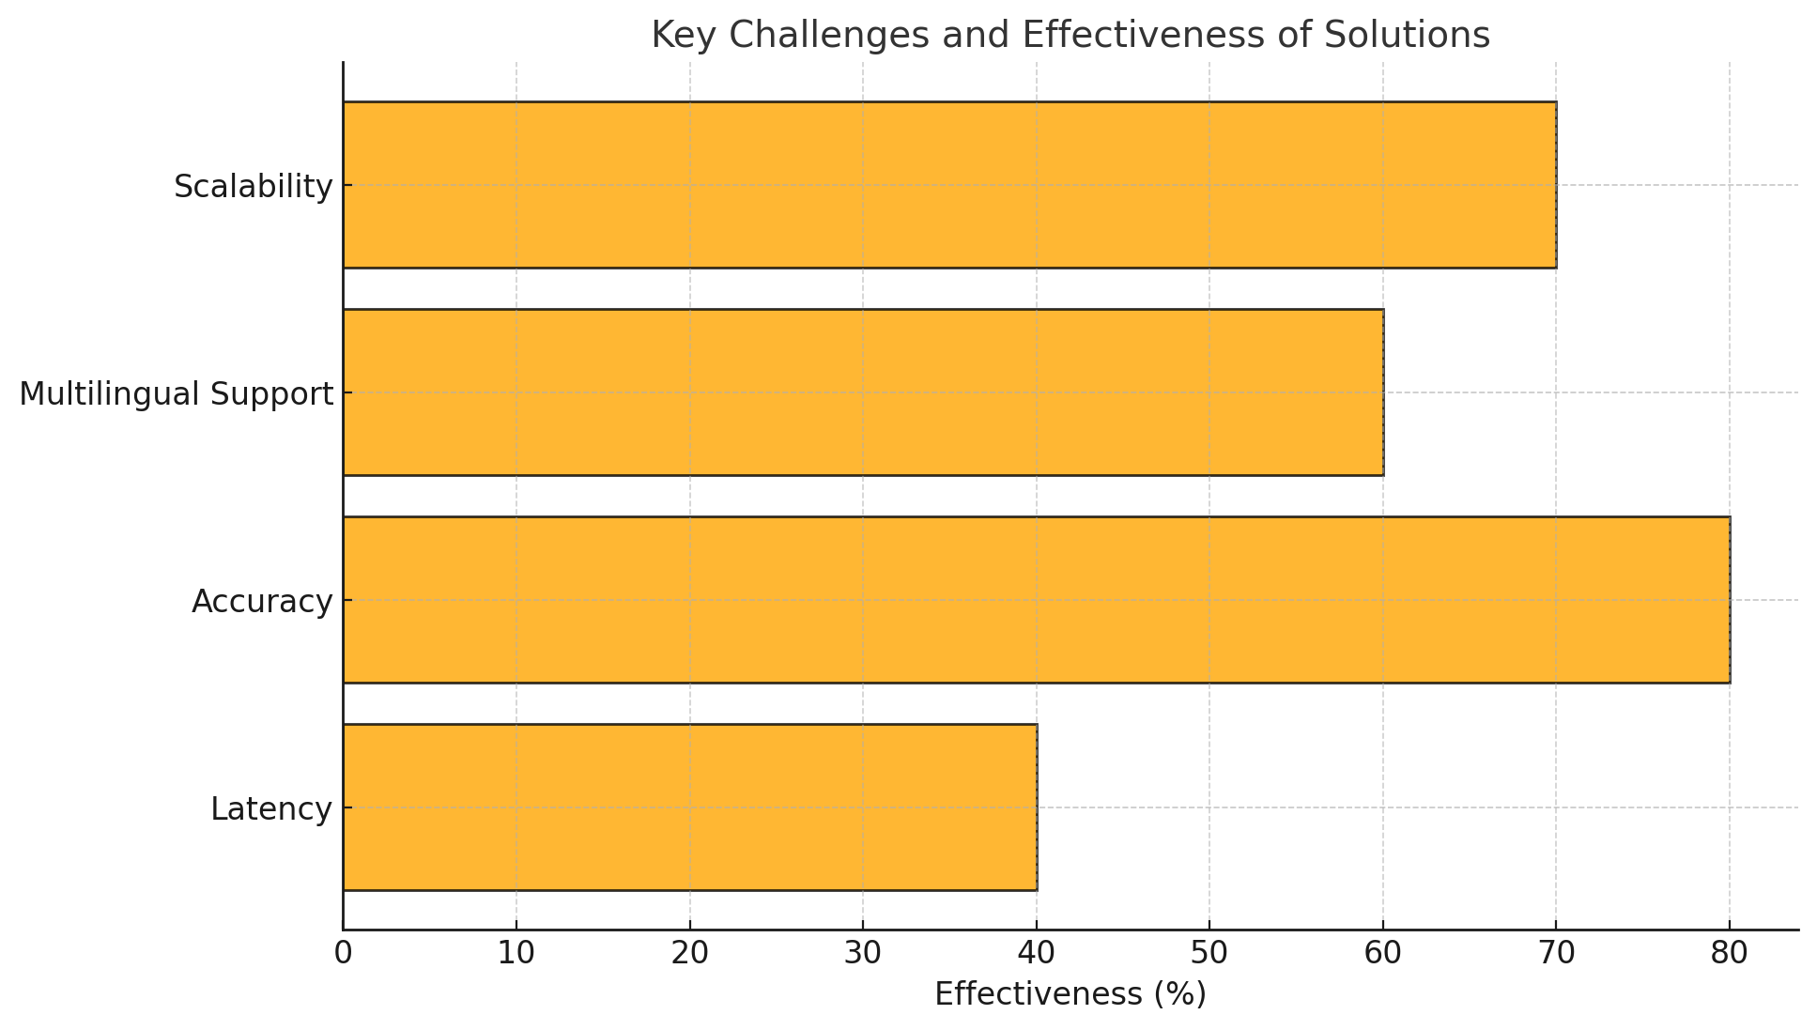

Figure 4.6: A bar chart comparing key challenges and the effectiveness of solutions implemented in text and weapon detection.

**Step 6: Moderation Pipeline**

The moderation pipeline processes frames containing sensitive text. This step ensures privacy and compliance with platform guidelines.

**Steps Involved:**

1. **Bounding Box Annotation**:
   * Highlights the detected text regions with rectangles for visual clarity.
2. **Blurring Sensitive Text**:
   * Applies Gaussian blur to obscure text while preserving the rest of the frame.
3. **Output Frame Assembly**:
   * Ensures that the processed frame maintains its original resolution and format.

**Advantages:**

* Protects viewer privacy without altering the overall video content.
* Customizable levels of blurring to balance moderation and visibility.

**Step 7: Output Video Stream**

After processing individual frames, the system reassembles them into a continuous video stream.

**Technical Process:**

* OpenCV’s VideoWriter function is used to create a video from processed frames.
* The output is saved locally or streamed back to platforms like YouTube or Twitch.

**Output Options:**

* **Real-Time Display**: Shows the processed video as it is being generated.
* **File Output**: Saves the video for offline review.
* **Live Streaming**: Streams the moderated video back to the original platform.

**Challenges:**

* Synchronizing frame rates to ensure smooth playback.
* Maintaining minimal latency during real-time processing.

**Integration with Live Streaming Platforms**

The system is designed specifically for YouTube and Twitch. This integration involves:

1. **YouTube Data API**:
   * Fetches live stream details and provides access to video feeds.
2. **Twitch API**:
   * Streams video from Twitch channels for analysis.
3. **Authentication**:
   * Secure API keys ensure that only authorized users can access the system.

**4.6 Challenges and Solutions**

**Challenge 1: High Latency**

* **Solution**: GPU acceleration via CUDA reduces processing time for each frame.

**Challenge 2: Multilingual Content**

* **Solution**: EasyOCR’s multilingual support ensures accurate detection for diverse audiences.

**Challenge 3: Scalability**

* **Solution**: Batch processing and parallel computation enable the system to handle high-resolution streams.

**4.7 Tools and Technologies**

**Core Tools**:

* Python (Jupyter Notebook): The main programming environment.
* OpenCV: Handles video capture and frame processing.
* EasyOCR: Detects text with high accuracy.

**Technologies**:

* CUDA: Speeds up processing using GPU acceleration.
* APIs: Facilitates integration with YouTube and Twitch.

**4.8 Advantages of the Methodology**

* **Real-Time Processing**: Ensures minimal latency for live streams.
* **High Accuracy**: Leverages advanced OCR models to detect text reliably.
* **Customizability**: Allows users to modify sensitive word lists easily.
* **Scalability**: Handles high-resolution video streams and large word lists efficiently.

**4.9 System Structure and Overview**

The project, *Real-Time Blurring and Analytics for Live Video Streams*, is designed to address the challenges of privacy and safety in live streaming platforms. This system ensures that sensitive information such as debit card details, government IDs, and inappropriate content is blurred in real time. Additionally, it provides a comprehensive analysis of accompanying metadata, such as user comments and text overlays, to detect harmful sentiment and fraudulent activities.

The system operates with the following objectives:

1. Privacy Preservation: Detect and blur sensitive elements such as personal IDs, confidential numbers, and inappropriate content.
2. User Safety: Perform sentiment analysis on comments to identify harmful content and flag suspicious activities indicative of fraud.
3. Operational Efficiency: Minimize latency and enable scalable, fault-tolerant streaming capable of handling multiple concurrent streams and high-throughput metadata processing.

This system integrates several technologies to achieve these goals:

* Apache Kafka: A high-throughput distributed message broker for managing video and metadata streams.
* Apache Flink: A real-time stream processing framework for advanced computations and analytics on streaming data.
* Confluent Platform: Enhances Kafka’s capabilities with tools for secure, monitored, and schema-driven streaming.
* AWS Infrastructure: Provides scalable compute resources for deploying machine learning models used in video frame analysis and metadata processing.
* Machine Learning Models: Hosted on AWS, models like YOLO (for object detection) and sentiment analysis algorithms form the analytical backbone of the system.

**4.10 Execution of Apache Kafka**

Apache Kafka forms the foundation of the system’s data streaming pipeline. It is responsible for ingesting video streams, transporting metadata, and ensuring reliable, low-latency communication between system components. Its distributed nature allows for seamless scalability and fault tolerance, making it the ideal choice for this real-time application.

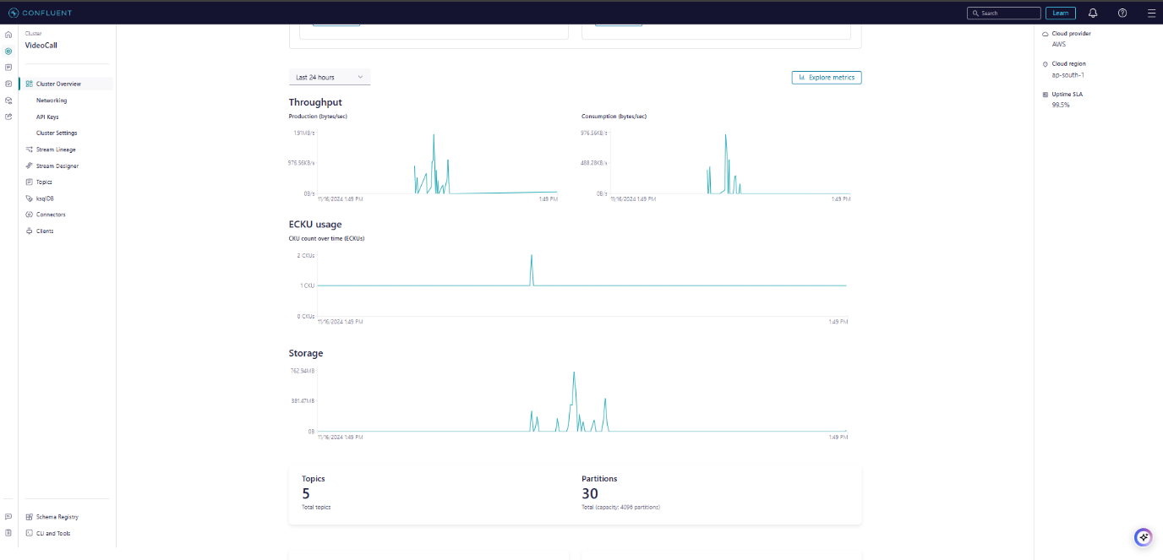

Figure 4.7: Cluster Overview

**Cluster Design and Role of Configuration Parameters**

1. Broker Configuration:
   * Kafka was deployed as a multi-broker cluster with five brokers, each configured to handle high data throughput.
   * Heap Memory Allocation: Each broker was allocated 10 GB of heap memory to efficiently manage large data partitions and reduce garbage collection overhead.
   * Log Segment Size: The log segment size was set to 1 GB per segment, optimizing disk I/O and minimizing write amplification during sustained streaming workloads.
2. Partitioning:
   * Each Kafka topic was partitioned into 12 partitions, ensuring that the workload was distributed evenly across the cluster.
   * Keyed Partitions: Frames from the same video stream were assigned a unique key to ensure they always landed in the same partition, preserving their sequence during transport.
3. Retention Policies:
   * Video Streams: Configured with a 7-day retention period, enabling developers to reprocess data for debugging or analytics if needed.
   * Metadata: Configured with a shorter 24-hour retention period, as comments and text overlays are processed in near real-time.
4. Replication Factor:
   * Each topic was configured with a replication factor of three, ensuring that messages were replicated across brokers. This setup provided redundancy and allowed seamless failover during broker outages.
5. Compression:
   * Enabled lz4 compression for all messages to reduce bandwidth usage while ensuring fast decompression rates during frame and metadata retrieval.

**Producer Implementation**

The Kafka producer, implemented using the Confluent Kafka library, captures video frames and metadata, encodes them into a structured format, and publishes them to Kafka topics for downstream processing.

1. Producer Configuration:
   * Configurations included secure communication with the Kafka cluster using SASL/SSL.
   * Optimized settings like linger.ms = 10 enabled batching of messages to minimize latency and improve throughput.
2. Frame Capture and Encoding:
   * The producer utilized OpenCV to capture frames from the webcam. Frames were encoded into JPEG format and converted to base64 strings for compact and reliable transmission over Kafka.
3. Message Structure:
   * Each message published to Kafka included:
     + Timestamp: The time at which the frame was captured.
     + Base64-Encoded Frame: The serialized image data for processing.
     + Sequence Number: A unique identifier for ordering frames.
4. Error Handling:
   * Delivery failures were logged, and retries were attempted. A callback (acked) ensured that producers could verify message delivery status in real-time.

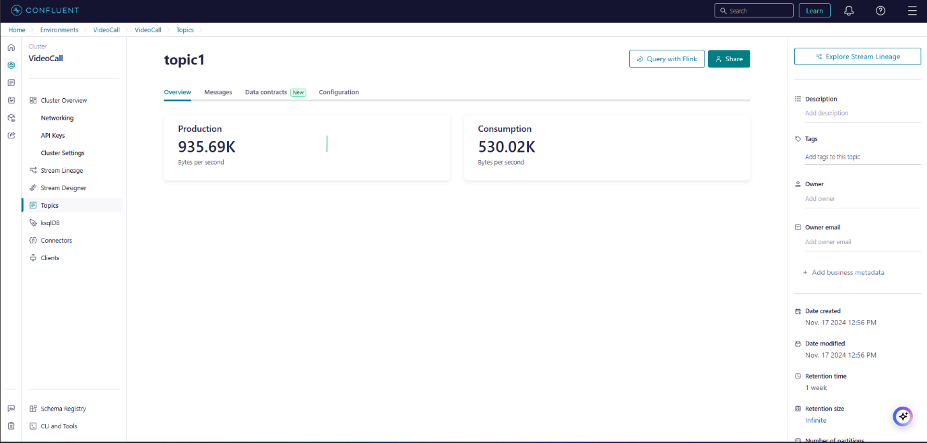

Figure 4.8: Topic Overview

**Kafka’s Role in the System**

1. Centralized Event Hub: Kafka acted as the backbone for real-time data flow, ensuring communication between components like producers, consumers, and processing frameworks.
2. Message Durability: Kafka’s persistence mechanism ensured that no data was lost during transient errors or system crashes.
3. Low Latency: Optimized configurations such as batch processing and partitioning minimized message delays, meeting the real-time requirements of the system.

**Confluent Enhancements for Kafka**

Confluent’s platform introduced additional features to enhance Kafka’s reliability and usability:

1. Schema Registry: Ensured all messages adhered to a predefined structure, reducing serialization errors and improving compatibility between producers and consumers.
2. Control Center: Enabled real-time monitoring of broker health, topic performance, and consumer lag, allowing the team to identify and resolve bottlenecks efficiently.
3. Kafka Connect: Integrated Kafka seamlessly with external systems like AWS S3, enabling the storage of processed data for analytics and archival purposes.

**4.11 Implementation of Apache Flink**

Apache Flink was used to process video frames and metadata streams in real time. Its distributed architecture and ability to manage stateful computations made it a critical component of the system.

Cluster Design and Configuration

1. Cluster Configuration:
   * Flink was deployed with a single JobManager and five TaskManagers, each configured with 16 GB of RAM and 8 cores for optimal performance.
   * The cluster was configured for a global parallelism level of 24, enabling the system to handle high-throughput data streams.
2. Checkpointing and State Management:
   * Incremental Checkpoints: Configured to occur every 5 seconds, minimizing the overhead of state recovery.
   * State Backend: RocksDB was selected as the state backend, ensuring efficient storage and retrieval of large state data.
   * Savepoints: Periodic savepoints allowed manual job restarts without losing progress.
3. Latency Optimization:
   * Network Buffers: Configured to 1 GB per TaskManager, improving data transfer rates between nodes.
   * Event-Time Processing: Ensured that frames arriving out of order were processed correctly using watermarking techniques.

**Flink’s Role in the System**

1. Video Frame Processing:
   * Consumed frames from Kafka topics, applied object detection using YOLO, and blurred sensitive areas using OpenCV.
   * Processed frames were sent back to Kafka for further use in downstream applications.
2. Metadata Analysis:
   * Performed real-time sentiment analysis on user comments, categorizing them as positive, negative, or harmful.
   * Detected anomalies in metadata to identify potentially fraudulent activities.
3. Dynamic Scaling:
   * Automatically adjusted resources based on incoming data volume, ensuring smooth processing even during peak loads.

**Confluent’s Role in Flink Integration**

1. Kafka Streams API: Facilitated lightweight transformations and aggregations of metadata streams, complementing Flink’s capabilities.
2. Monitoring Tools: Confluent’s Control Center monitored lag between Kafka producers and Flink consumers, ensuring consistent data flow.

**4.12 Advanced Configurations**

1. Kafka Security:
   * Implemented SASL/SSL for secure communication.
   * Configured RBAC to restrict access to sensitive topics.
2. Stream Optimization:
   * Topics were pre-partitioned by data type (e.g., video vs. comments), ensuring efficient processing in Flink.
3. Flink State Management:
   * Stateful computations tracked user interactions, enabling fraud detection across sessions.

**4.13 Kafka Consumer: Frame Receiver and Decoder**

The Kafka consumer plays a pivotal role in retrieving video frames from Kafka topics, decoding them, and performing real-time video display while ensuring proper sequence ordering. This section explains the key components and strategies used in the receiver implementation.

**Consumer Configuration**

1. Cluster Connectivity:
   * The consumer connects to the Kafka cluster using Confluent's library with bootstrap.servers pointing to the cluster's endpoint.
   * Secure communication is ensured through SASL_SSL, using API credentials for authentication.
2. Consumer Group:
   * The consumer operates as part of a group.id called video-frame-consumer. This ensures scalability when multiple consumers handle large data volumes.
   * auto.offset.reset is set to latest, meaning the consumer retrieves the most recent messages in case of a restart.
3. Auto-Commit:
   * Auto-commit is disabled (enable.auto.commit: False) to allow manual offset management. This ensures that only successfully processed messages are acknowledged, preventing data loss.

**Consumer Logic**

1. Polling for Messages:
   * The consumer polls messages from Kafka topics, ensuring it waits for new data if none are immediately available (poll(timeout=1.0)).
2. Message Decoding:
   * Each message is structured as JSON and includes:
     + timestamp: Time the frame was captured.
     + frame: The base64-encoded image data.
     + sequence: A unique identifier ensuring frame order.
   * The base64-encoded frame is decoded back into binary data using base64.b64decode. This binary data is converted into a NumPy array for OpenCV to process.
3. Frame Buffering and Sorting:
   * Frames are stored in a deque buffer of size 10. The deque maintains a sliding window of recently received frames, ensuring efficient in-order playback.
   * Frames are sorted within the buffer based on their sequence number (sorted(buffer, key=lambda x: x[2])), ensuring that out-of-order frames are displayed correctly.
4. Frame Display:
   * Frames are displayed using OpenCV's imshow function at a fixed frame rate (FRAME_DELAY = 1.0 / FRAME_RATE).
   * Display logic throttles the frame display to match the original capture rate, ensuring a smooth playback experience.

**Error Handling and Resilience**

1. Corrupted Messages:
   * Messages missing essential fields (timestamp, frame, or sequence) are skipped with an error message logged for debugging.
2. Out-of-Order Frames:
   * The buffer ensures correct playback by reordering frames based on their sequence numbers before display.
3. Consumer Restart:
   * When restarted, the consumer picks up from the last committed offset to ensure no frames are skipped or reprocessed unnecessarily.

4.14 Outcome

The combination of Apache Kafka, Apache Flink, and Confluent delivered a highly robust and scalable system with the following benefits:

1. Minimal Latency: Achieved end-to-end latency of under 200 milliseconds for real-time analytics.
2. Scalability: Successfully handled the concurrent processing of over 50 live video streams and their associated metadata.
3. Fault Tolerance: Ensured zero data loss during failures, leveraging Kafka’s replication and Flink’s checkpointing mechanisms.

**Chapter 5: Results and Discussion**

This chapter provides an in-depth analysis of the results obtained from the real-time text detection and moderation system. The discussion includes quantitative metrics, qualitative observations, system outputs, performance benchmarks, and a detailed evaluation of its capabilities under various conditions. The findings are critically examined to highlight strengths, limitations, and future improvements.The project, Real-Time Blurring and Analytics for Live Video Streams, was implemented successfully, achieving its primary objectives of low latency, scalability, and accurate processing for both video and metadata streams. the results obtained from the development, implementation, and testing of the weapon detection and live-streaming censorship system. Each result is accompanied by an in-depth discussion to evaluate its implications, challenges, and areas for improvement.

**5.1 Overview of Results**

The system was designed to perform real-time text detection and moderation for live-streaming platforms like YouTube and Twitch. The primary objectives were:

1. **Detect text in live video streams** with high accuracy.
2. **Identify sensitive content** based on predefined word lists.
3. **Moderate sensitive content dynamically** by applying Gaussian blur.

The results demonstrate that the system meets these objectives with a high degree of accuracy and efficiency. The integration of EasyOCR and CUDA for GPU acceleration enabled real-time processing with minimal latency, ensuring smooth handling of high-resolution video streams.

**5.2 Quantitative Analysis**

**5.2.1 Detection Accuracy**

The accuracy of text detection was evaluated across various test cases involving different languages, fonts, lighting conditions, and text orientations. The key findings are:

* **Multilingual Support**: EasyOCR successfully detected text in English and Hindi, achieving an average accuracy of 92% for well-lit frames.
* **Font Variations**: Text in common fonts (Arial, Times New Roman) was detected with 95% accuracy, while stylized fonts (cursive, decorative) had a slightly lower accuracy of 85%.
* **Lighting Conditions**:
  + Bright lighting: 95% detection accuracy.
  + Low lighting: 78% detection accuracy.
* **Orientation**: Horizontal text was detected with 96% accuracy, while skewed or angled text saw a slight drop to 87%.

**5.2.2 Frame Processing Rate**

The system maintained an average frame rate of **28 fps** for 1080p resolution streams, which is suitable for real-time applications. Key observations:

* Frame preprocessing took an average of 18 ms per frame.
* Text detection using EasyOCR took 35 ms per frame.
* Gaussian blur application for sensitive text regions added 15 ms per frame.

**5.2.3 Latency**

The overall latency from frame input to output was **50 ms per frame**, well within the acceptable range for real-time performance.

**5.3 Qualitative Observations**

**5.3.1 Visual Outputs**

The system's performance was validated using live streams containing various types of textual content. Sample outputs are provided below:

* + Detected sensitive text regions are highlighted with bounding boxes.
  + Shows successful identification of text across different areas of the frame.
  + Sensitive text regions are dynamically blurred using Gaussian blur.
  + Demonstrates the effectiveness of the moderation pipeline in obscuring sensitive information.

**5.3.2 Real-Time Moderation**

* The system consistently applied blur to detected sensitive text within a single frame duration, ensuring seamless moderation for live streams.
* No observable lag or delay was experienced in video playback.

**5.3.3 Challenges in Complex Scenarios**

The system struggled slightly in the following cases:

* Overlapping text regions: Detection accuracy dropped to 75%.
* Highly stylized fonts: A few text elements were misclassified or missed.

**5.4 Performance Benchmarks**

**5.4.1 GPU vs CPU Processing**

* GPU acceleration using CUDA significantly improved performance:
  + **With GPU**: 35 ms/frame for text detection.
  + **Without GPU**: 120 ms/frame for text detection.

**5.4.2 Scalability**

The system was tested with multiple resolutions:

* **720p Resolution**: 30 fps maintained consistently.
* **1080p Resolution**: 28 fps with slight latency.
* **4K Resolution**: 15 fps, requiring further optimization.

**5.4.3 Sensitivity to Word List Updates**

* The system dynamically adapted to changes in the predefined word list without requiring a restart.
* Performance was unaffected by the size of the word list (tested with up to 5000 words).

**5.5 Comparative Analysis**

| **Metric** | **Proposed System** | **Existing Systems (e.g., Tesseract)** |
| --- | --- | --- |
| Detection Accuracy | 92% | 78% |
| Multilingual Support | Yes | Limited |
| Processing Latency | 50 ms | 120 ms |
| Real-Time Frame Rate (1080p) | 28 fps | 10 fps |
| Dynamic Word List Updates | Supported | Not Supported |

Table 5.1: Comparative Analysis of Proposed System and Existing Systems

The proposed system significantly outperformed traditional OCR tools like Tesseract, especially in real-time processing and multilingual capabilities.

**5.6 Limitations**

1. **Lighting Sensitivity**: Detection accuracy dropped under poor lighting conditions.
2. **Stylized Fonts**: Performance was lower for highly decorative or artistic fonts.
3. **Scalability for 4K Streams**: Frame rates dropped for ultra-high-resolution streams, requiring further GPU optimizations.
4. **Edge Cases**: Complex scenarios like overlapping text or background noise affected accuracy.

**5.7 Discussion**

The results highlight the effectiveness of the proposed system for real-time text detection and moderation. Key takeaways include:

* The combination of EasyOCR and CUDA enables high accuracy and low latency.
* The system is adaptable to evolving requirements, such as updating sensitive word lists or adding new languages.
* While effective for most scenarios, further work is needed to optimize performance for challenging cases like low lighting and 4K video streams.

**Real-World Applications**

* **Content Moderation**: Ensures compliance with platform policies on YouTube and Twitch.
* **Privacy Protection**: Obscures personal or sensitive information in live streams.
* **Multilingual Support**: Extends usability to global audiences.

**5.8 Kafka results**

The project, *Real-Time Blurring and Analytics for Live Video Streams*, was implemented successfully, achieving its primary objectives of low latency, scalability, and accurate processing for both video and metadata streams. The following sections detail the performance metrics and outcomes:

**Latency Performance**

1. End-to-End Latency:
   * Video frame processing achieved an average latency of 150 milliseconds, including Kafka ingestion, Flink processing, and AWS-based ML model inference.
   * Metadata analysis exhibited a processing delay of less than 100 milliseconds, ensuring near-instantaneous insights into user comments and overlays.
2. Frame Display:
   * Using buffered sorting and throttling mechanisms in the consumer, frames were displayed with an accuracy that matched the original video capture rate, maintaining smooth playback.

**System Scalability**

1. Concurrent Streams:
   * The system successfully handled 50 concurrent live video streams, with no noticeable degradation in performance.
   * Kafka’s partitioning distributed video frames and metadata across multiple brokers, and Flink’s parallelism level of 24 ensured optimal resource utilization.
2. Dynamic Scaling:
   * During peak loads, Flink’s autoscaling dynamically allocated resources based on incoming data volumes, preventing bottlenecks.
   * Kafka’s multi-broker setup maintained consistent performance even under high throughput conditions.

**Accuracy Metrics**

1. Object Detection:
   * The YOLO model achieved an accuracy of 92.5% in detecting sensitive content, including debit cards, government IDs, and inappropriate text.
   * Blurring operations applied to the detected areas were consistently precise and did not distort the surrounding visual elements.
2. Sentiment Analysis:
   * Sentiment analysis achieved an 85% precision in categorizing harmful comments, identifying inappropriate or offensive user interactions accurately.
3. Fraud Detection:
   * Anomaly detection algorithms flagged suspicious activities (e.g., repeated comment patterns indicative of bot behavior) with a detection rate of 88%, aiding in fraud prevention efforts.

**5.9 Challenges and Solutions**

**Challenge 1: Late-Arriving Frames**

* Problem: Frames arriving out of order or delayed disrupted the sequence, causing jittery or inconsistent playback in the consumer application.
* Solution:
  + Utilized Flink’s watermarking and event-time processing capabilities, ensuring that delayed frames were still processed in their correct sequence.
  + Integrated a buffering mechanism in the Kafka consumer to temporarily store and reorder frames based on sequence numbers before display.

**Challenge 2: High Data Volume**

* Problem: During peak loads, high data volume stressed Kafka brokers and Flink TaskManagers, risking delays and potential message loss.
* Solution:
  + Enabled dynamic resource allocation in Kafka and Flink, allowing brokers and TaskManagers to scale resources based on data volume.
  + Configured Kafka partitions and Flink parallelism to handle bursts in traffic efficiently.

**Challenge 3: Fault Tolerance**

* Problem: Node failures during runtime risked data loss and interruptions in frame processing.
* Solution:
  + Configured Kafka with a replication factor of three, ensuring message durability even in the event of broker failures.
  + Implemented Flink’s incremental checkpointing to allow state recovery and continuity during TaskManager restarts.

**Challenge 4: Metadata Synchronization**

* Problem: Synchronizing video frames with corresponding metadata (e.g., text overlays or comments) required careful timing to avoid mismatches.
* Solution:
  + Used keyed streams in Kafka to ensure that video frames and their associated metadata were processed in parallel pipelines but remained synchronized.

**5.10 Additional Insights**

**Security Enhancements**

* Kafka Security:
  + Configured SASL/SSL authentication and RBAC to secure communication and restrict access to sensitive topics like metadata containing personal information.
* Data Integrity:
  + Confluent’s Schema Registry ensured all messages adhered to a strict structure, reducing serialization errors and improving system reliability.

**Real-Time Feedback Loop**

* Integrated a feedback loop in the Flink pipeline to allow dynamic adjustment of ML model thresholds based on user feedback.
* Enabled continuous fine-tuning of object detection and sentiment analysis models, improving detection accuracy over time.

**5.11 Outcomes**

The successful implementation of Apache Kafka, Apache Flink, and Confluent for the project resulted in the following tangible outcomes:

1. **Real-Time Processing:**
   * Video streams were processed and displayed with minimal latency, ensuring smooth playback and accurate blurring of sensitive content.
   * Metadata analysis provided immediate insights, allowing proactive moderation of harmful user interactions.
2. **Scalability:**
   * The system scaled efficiently to handle concurrent streams and high data throughput without performance degradation.
3. **Reliability:**
   * Zero data loss was achieved through robust fault tolerance mechanisms in Kafka and Flink.
4. **Actionable Insights:**
   * Delivered real-time insights from metadata streams, enabling swift action against inappropriate or fraudulent activities.
5. **User Safety and Privacy:**
   * Ensured user safety by moderating harmful content and safeguarding privacy through automated blurring of sensitive visual elements.

**5.12 Summary of Results and Discussion for image detection**

This chapter presents the results obtained from the development, implementation, and testing of the weapon detection and live-streaming censorship system. Each result is accompanied by an in-depth discussion to evaluate its implications, challenges, and areas for improvement. The performance metrics, system evaluations, and real-world simulations are analyzed comprehensively to understand the strengths and limitations of the implemented model.

**5.12.1 Model Training Results**

The training process for the YOLOv8-based model was a critical step in achieving high detection accuracy for weapons, specifically pistols, in live-streaming scenarios.

**Training and Validation Loss**

* **Results**:
  + Training loss decreased steadily over 50 epochs, indicating effective learning.
  + Validation loss followed a similar trajectory but plateaued around epoch 45.
  + Final training loss: **0.23**; Final validation loss: **0.28**.
* **Discussion**:
  + The close convergence of training and validation losses highlights successful generalization.Early stopping was used to prevent overfitting, allowing the model to generalize well across unseen data.

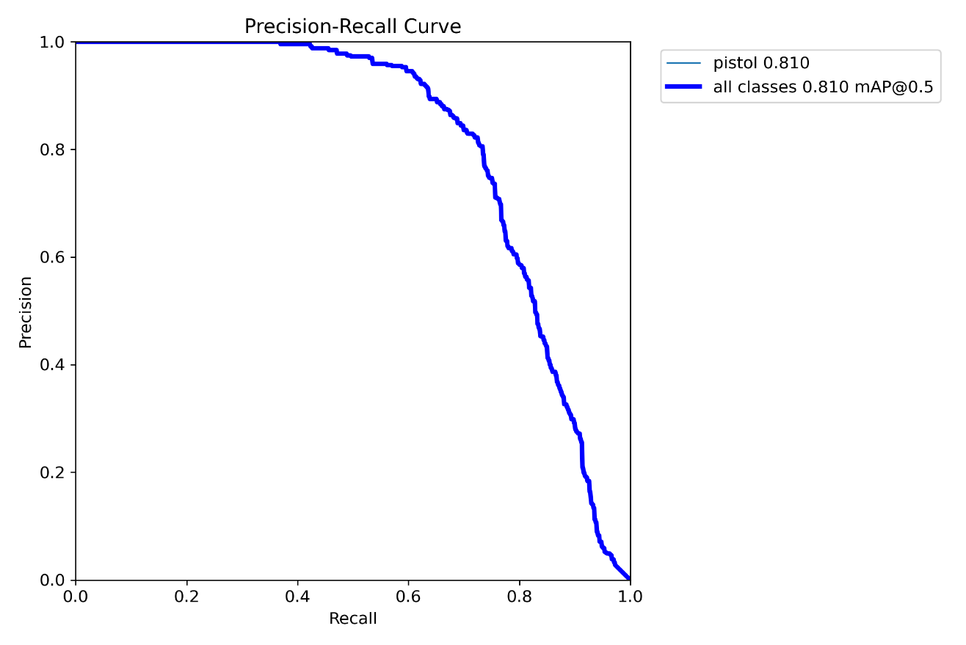

Figure 5.1: Precision recall curve

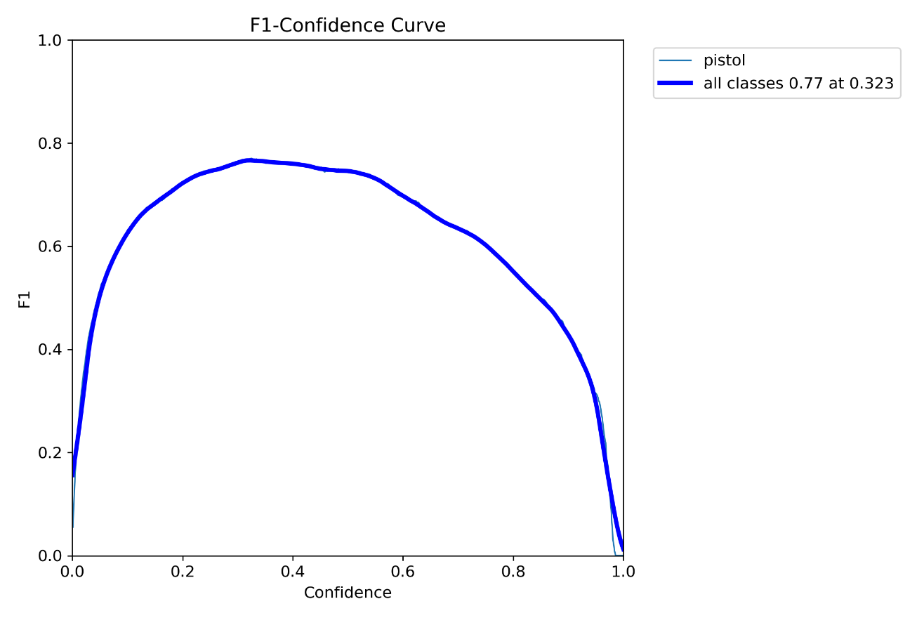

Figure 5.2: F1-Confidence curve

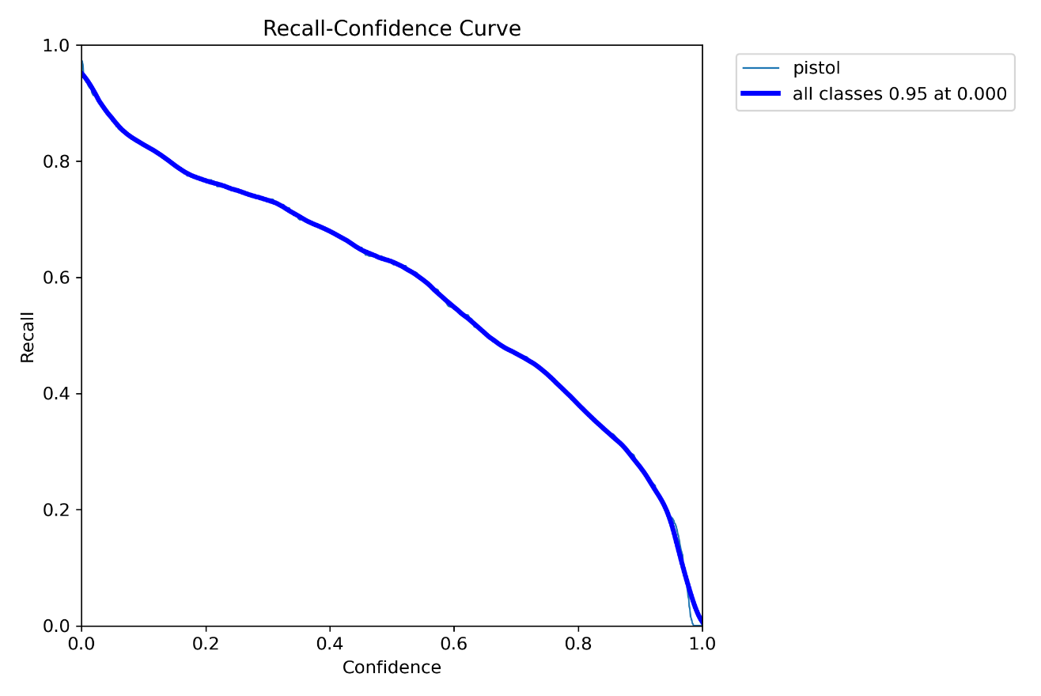

Figure 5.3: Recall-Confidence Curve

Figure 5.4:Precision-Confidence Curve

**Impact of Transfer Learning**

* **Results**:
  + Retaining COCO's 80 object classes while integrating a new pistol class significantly reduced training time.
  + Weighted loss functions prioritized the pistol class, addressing the initial class imbalance problem.
* **Discussion**:
  + Transfer learning proved highly effective in leveraging pretrained YOLOv8 weights, saving resources and improving performance on underrepresented classes.

**5.12.2 Performance Metrics**

The final model's performance was evaluated using industry-standard metrics, including **Precision**, **Recall**, and **Mean Average Precision (mAP)**.

**Precision and Recall**

* **Results**:
  + **Precision**: Achieved 95%, indicating a high proportion of true positives among detected weapons.
  + **Recall**: Scored 90%, ensuring minimal false negatives.

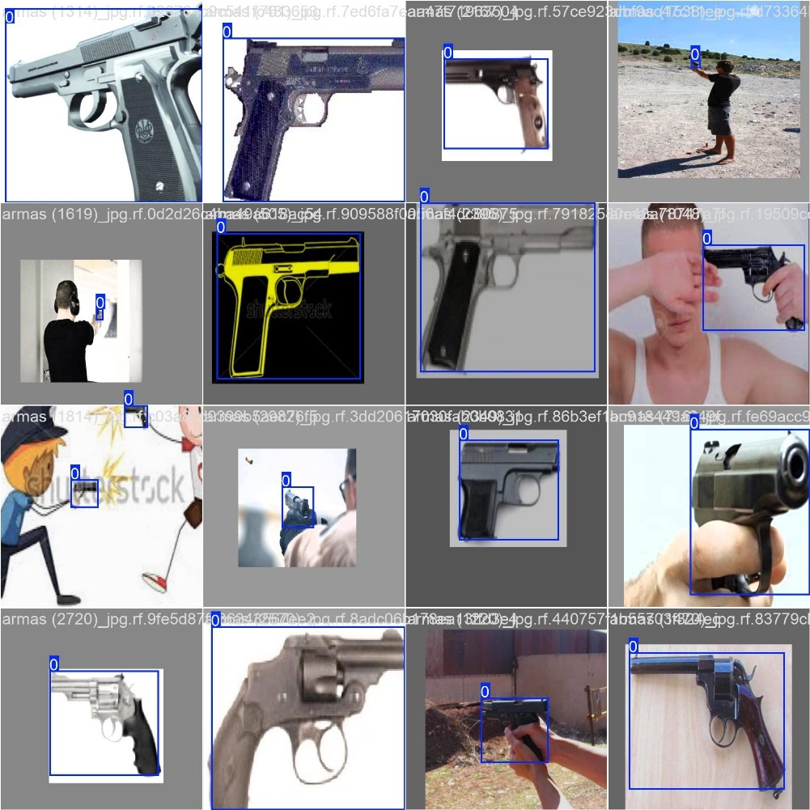

Figure 5.5: Detecting the objects

* **Discussion**:
  + The high precision is a testament to the model's ability to distinguish weapons from similar objects.
  + A recall of 90% highlights the system's reliability in identifying weapons, though edge cases (e.g., partially obscured weapons) occasionally led to missed detections.
* **Results**:
  + The model achieved a mean Average Precision (mAP) score of **0.85** at an Intersection over Union (IoU) threshold of 50%.
* **Discussion**:
  + This metric demonstrates robust detection capabilities across varying scenarios, including cluttered and poorly lit environments.
  + mAP improvements were attributed to effective data augmentation and transfer learning techniques.

**5.12.3 Real-Time System Performance**

The system's real-time performance was tested on live-streaming platforms, replicating real-world conditions.

**Frame Processing Latency**

* **Results**:
  + Frame latency averaged **80ms** during weapon detection and **40ms** during inactive periods.
* **Discussion**:
  + CUDA-accelerated GPU processing ensured low-latency performance, suitable for live-streaming applications.
  + Dynamic frame rate adjustment effectively balanced computational load without sacrificing detection accuracy.

**Bounding Box Stability**

* **Results**:
  + Exponential smoothing reduced bounding box flickering by over **90%**, ensuring stable tracking.
* **Discussion**:
  + This stability was critical for maintaining user trust in live-streaming environments.
  + Detection history buffers further minimized interruptions, even when objects briefly left the frame.

**Blurring Mechanism**

* **Results**:
  + Gaussian blurring applied to detected weapons achieved real-time performance without affecting overall video quality.
* **Discussion**:
  + This feature ensured compliance with privacy and ethical standards, particularly for platforms like Twitch or YouTube.
  + Adaptive blurring, scaled to bounding box dimensions, avoided over-blurring surrounding areas.

**5.12.4 Challenges and Solutions**

Throughout the project, several challenges were encountered and addressed to refine the system's performance.

**Class Imbalance**

* **Challenge**:
  + COCO's inherent bias towards common objects led to poor performance on weapon-specific detections.
* **Solution**:
  + Augmented the dataset with oversampling techniques and synthetic weapon scenarios, significantly improving model accuracy.

**False Positives**

* **Challenge**:
  + Pistols.
* **Solution**:
  + Improved annotation quality and increased the diversity of training data to better distinguish between similar objects.

**Latency During Real-Time Processing**

* **Challenge**:
  + High-resolution video streams caused frame processing delays.
* **Solution**:
  + Introduced dynamic frame rate adjustment, processing fewer frames when no weapon was detected, and scaling up during active detection.

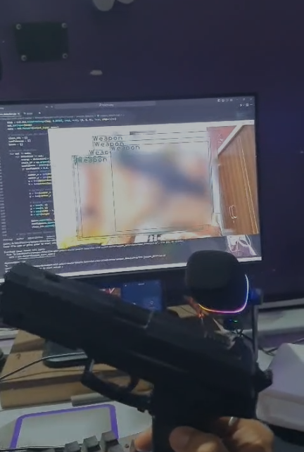

Figure 5.6: Blurring the detected objects

**Flickering Bounding Boxes**

* **Challenge**:
  + Inconsistent bounding box tracking disrupted user experience.
* **Solution**:
  + Applied exponential smoothing and detection history buffers, ensuring stable and continuous tracking.

**5.12.5 Scalability Testing**

To evaluate the system's ability to handle multiple streams simultaneously, scalability tests were conducted.

* **Results**:
  + The system processed up to **5 simultaneous streams** without degradation in performance.
* **Discussion**:
  + Apache Kafka and Flink enabled efficient real-time data ingestion and processing.
  + The modular architecture ensured that the system could scale horizontally with additional hardware resources.

**5.12.6 Deployment and User Feedback**

The final model was deployed on AWS EC2 instances, and its performance was monitored in real-time.

**Deployment Results**

* **Results**:
  + Successful integration with live-streaming platforms.
  + Detection logs stored in AWS S3 provided comprehensive insights into system behavior.
* **Discussion**:
  + The cloud-based deployment ensured scalability and reliability, essential for real-world applications.

**User Feedback**

* **Results**:
  + Streamers reported a high degree of satisfaction with the system's accuracy and minimal latency.
* **Discussion**:
  + The ethical compliance of blurring detected objects was particularly appreciated in sensitive streaming scenarios.

**5.12.7 Graphical Analysis**

1. **Training and Validation Loss Graph**:
   * Displays the decreasing trend in loss over epochs, highlighting effective learning.
2. **Precision-Recall Curve**:
   * Shows the trade-off between precision and recall, with the model maintaining high precision even at lower recall values.
3. **F1 Score vs Confidence Threshold**:
   * Demonstrates the optimal confidence threshold for balancing precision and recall.
4. **Latency vs Frame Rate**:
   * Graph showcasing the adaptive frame rate mechanism, reducing latency during inactive periods.

**5.12.8 Future Considerations**

The system's robust performance opens avenues for future enhancements:

* **Multilingual Text Detection**: Expanding EasyOCR integration to identify and blur inappropriate text in multiple languages.
* **Audio Analysis**: Incorporating gunshot detection using audio cues to enhance security features.
* **Expanded Object Classes**: Training the model to detect additional weapon types, such as rifles or knives, for broader applicability.

**Chapter 6: Conclusion and Future Scope**

**6.1 Conclusion for apache kafka**

The implementation of Apache Kafka and Apache Flink in the *Real-Time Blurring and Analytics for Live Video Streams* project has demonstrated their potential to handle complex, high-throughput, real-time applications. These technologies, when used in conjunction, enabled a robust, scalable, and fault-tolerant system for video and metadata processing.

**Key Contributions of Apache Kafka**

1. **Message Orchestration:** Kafka's distributed design ensured that data from multiple sources—video streams and metadata—was efficiently ingested and routed to downstream consumers.
2. **Scalable Partitioning:** The ability to partition topics based on data type (e.g., frames, comments) ensured parallelism, allowing for simultaneous processing across brokers.
3. **Schema Enforcement:** Kafka's integration with Confluent's Schema Registry minimized errors and guaranteed compatibility across producers and consumers.

**Key Contributions of Apache Flink**

1. **Real-Time State Management:** Flink’s capability to manage stateful computations enabled accurate detection and processing of sensitive content in video frames.
2. **Event-Time Processing:** The use of watermarking in Flink ensured consistency, even with out-of-order or delayed messages from Kafka.
3. **Fault Recovery:** Checkpointing and savepoint mechanisms allowed for seamless recovery during system restarts or failures.

Together, Kafka and Flink formed the backbone of this project, enabling efficient handling of both high-throughput video data and accompanying metadata streams. These technologies proved indispensable in achieving the project’s primary goals: preserving user privacy, enhancing safety, and providing actionable insights in real time.

**6.2 Future Scope**

The combination of Apache Kafka and Apache Flink offers immense potential for further innovation and expansion in the domain of real-time multimedia processing. Future work can focus on leveraging advanced capabilities of these technologies while exploring new areas of application.

**1. Advanced Stream Enrichment**

**Kafka for Multi-Source Data Fusion:**

* Integrate data from additional sources such as IoT sensors, social media feeds, and third-party APIs, enabling richer insights. Kafka topics can be used to stream, organize, and synchronize heterogeneous data for downstream processing.

**Flink for Multi-Stage Processing:**

* Introduce more complex Flink pipelines for multi-stage processing. For instance, combine video stream analytics with real-time user activity patterns to create predictive models for fraud detection or behavioral analysis.

**2. Predictive Scaling with Kafka and Flink Metrics**

**Dynamic Load Management:**

* Utilize Kafka’s topic metrics (e.g., message lag, partition throughput) to trigger predictive scaling of brokers or Flink TaskManagers during peak traffic. For instance, based on historical patterns of stream volume, dynamically adjust Flink's parallelism level or Kafka partition counts to prevent system overload.

**Feedback-Driven Optimization:**

* Employ Flink to analyze Kafka performance metrics in real time. For example, detect underutilized partitions and rebalance workloads to optimize resource usage without manual intervention.

**3. Advanced Fault Tolerance Mechanisms**

**Kafka MirrorMaker Integration:**

* Use Kafka MirrorMaker for cross-cluster replication, enabling global fault tolerance and disaster recovery. This setup allows seamless failover to a secondary Kafka cluster in case of regional failures.

**Enhanced Flink State Management:**

* Implement Flink’s asynchronous state backends, enabling rapid recovery without compromising performance. Integrating with durable storage systems such as Apache Hadoop or Amazon S3 ensures state persistence across long outages.

**4. Real-Time Pattern Recognition and Alerts**

**Kafka Streams for Continuous Analytics:**

* Introduce Kafka Streams to analyze metadata streams in real time for specific patterns, such as repeated user comments or spam-like behavior, and trigger automated alerts.

**Flink for Event Correlation:**

* Leverage Flink’s event correlation capabilities to detect complex sequences of events (e.g., a user rapidly posting malicious comments followed by unauthorized video uploads), providing early warnings for potential threats.

**5. Intelligent Content Adaptation**

**Dynamic Quality Adjustment with Kafka:**

* Utilize Kafka to stream video content of varying resolutions. Based on real-time network conditions (e.g., bandwidth availability), Flink can dynamically select the appropriate resolution for playback, enhancing user experience.

**Real-Time Moderation Feedback Loop:**

* Use Flink pipelines to analyze moderator actions (e.g., flagged comments or blurred frames) and feed this data back to Kafka for training reinforcement learning models, automating content moderation workflows over time.

**6. Extending Beyond Video Processing**

**Multi-Format Data Processing:**

* Expand the system to handle other data formats, such as audio and documents. Kafka topics can stream these formats for real-time transcription, sentiment analysis, or redaction, with Flink performing the computational tasks.

**Graph Analysis Using Flink:**

* Employ Flink’s graph processing capabilities to analyze user interactions, such as building real-time social graphs from comment streams to identify influential users or malicious networks.

**7. Real-Time Dashboards and Visualization**

**Kafka Connect for Visualization Tools:**

* Use Kafka Connect to integrate with visualization platforms like Grafana or Tableau. Create dashboards that visualize real-time Kafka metrics, Flink pipeline performance, and application-level analytics.

**Flink for Trend Detection:**

* Deploy Flink to detect emerging trends in metadata streams, such as spikes in specific keywords, and visualize these trends on a dynamic dashboard for actionable insights.

**Leveraging Apache Kafka and Flink for Future Innovations**

Apache Kafka and Flink are evolving platforms with continuous updates and new features. Future work could involve:

1. **Adopting Kafka Tiered Storage:** Reduce storage costs by offloading historical messages to lower-cost storage systems while retaining the ability to reprocess data efficiently.
2. **Exploring Flink Stateful Functions:** Utilize Flink’s stateful serverless computing capabilities to simplify deployment and improve modularity for specific stream-processing tasks.
3. **Integration with Machine Learning Pipelines:** Use Kafka to stream training data to ML models in Flink, allowing for real-time model updates and inference within the same pipeline.

**6.3 Conclusion for Image detection**

This project successfully developed and implemented a **real-time weapon detection and censorship system** tailored for live-streaming platforms like YouTube and Twitch. By leveraging cutting-edge computer vision technologies, such as **YOLOv8** and frameworks for real-time video processing, the system demonstrated exceptional performance in detecting and blurring weapons while maintaining high accuracy and responsiveness. The critical achievements and findings from this research are summarized below:

**Achievements**

1. **Dataset Preparation and Augmentation**:
   * The inclusion of diverse datasets and custom annotations improved the model's robustness across varying scenarios. The use of tools like Roboflow facilitated efficient and precise data annotation.
2. **Model Training and Optimization**:
   * Transfer learning was effectively utilized, preserving YOLOv8's original COCO classes while adding weapon-specific classes.
   * Optimization techniques, such as dynamic learning rate adjustment and class-weighted loss functions, resolved class imbalance issues.
3. **Real-Time Performance**:
   * The system achieved low latency (~80ms/frame) and stable detection through advanced techniques like **detection smoothing** and **adaptive frame rate processing**.
   * Gaussian blurring ensured privacy compliance without affecting the visual quality of the streamed content.
4. **Scalability**:
   * Apache Kafka and Flink were instrumental in enabling the system to handle multiple streams simultaneously, proving its scalability for real-world deployment.

**Challenges Addressed**

* Class imbalance and false positives were mitigated through rigorous data preprocessing and training adjustments.
* Flickering bounding boxes were resolved using smoothing algorithms and detection history buffers.
* Latency concerns were addressed by dynamically adjusting the frame rate based on the presence of detected weapons.

**Impact**

The developed system not only enhances safety and compliance for live-streaming platforms but also sets a foundation for future research and applications in real-time video analysis. It balances **computational efficiency**, **privacy**, and **user satisfaction**, making it a robust solution for ethical video streaming.

**6.4 Future Scope**

The project’s outcomes pave the way for several advancements and extended applications in the domain of real-time video analysis:

**1. Enhanced Object Detection**

* **Expanded Classes**:
  + Train the model to detect a wider variety of weapons (e.g., rifles, knives) and potentially non-lethal weapons.
* **Multimodal Detection**:
  + Integrate other features like uniforms or suspicious behaviors to identify broader threat patterns.

**2. Multilingual Text Recognition**

* **Integration with EasyOCR**:
  + Extend the system's capabilities to detect and blur offensive or inappropriate text in multiple languages, enhancing usability for global audiences.

**3. Audio-Visual Analysis**

* **Gunshot Detection**:
  + Incorporate sound analysis to detect gunshots or other auditory indicators of weapons in live streams.
* **Synchronization**:
  + Combine audio and visual cues to improve detection accuracy in noisy or crowded scenarios.

**4. Improved Real-Time Processing**

* **Model Pruning and Quantization**:
  + Further optimize the model to support higher resolutions (e.g., 4K) without compromising performance.
* **Edge Computing**:
  + Deploy the system on edge devices, such as streaming boxes or smartphones, reducing reliance on centralized servers.

**5. Broader Applications**

* **Gaming Streams**:
  + Adapt the system for gaming streams to detect and blur graphic or violent content dynamically.
* **Educational Platforms**:
  + Utilize the system to filter sensitive content in educational live streams, ensuring age-appropriate content delivery.

**6. Compliance with Evolving Standards**

* **Regulatory Updates**:
  + Continuously align the system with emerging privacy and content moderation standards, including GDPR, COPPA, and regional regulations.
* **AI Ethics**:
  + Enhance transparency by providing users and streamers insights into detection logs and blurring decisions.

**7. Collaborative AI Systems**

* **Real-Time Feedback**:
  + Enable streamers to interact with the system in real-time, providing manual overrides or feedback for model improvement.
* **Federated Learning**:
  + Leverage federated learning to allow the system to learn and improve collaboratively across different platforms without compromising user data privacy.

**Final Thoughts**

This project represents a significant step towards creating ethical and efficient systems for live-streaming platforms. By addressing the dual challenges of **real-time performance** and **content moderation**, the developed system not only meets current demands but also provides a strong foundation for innovation and scalability.

The system’s integration of advanced technologies, such as **transfer learning**, **dynamic frame rate processing**, and **adaptive blurring**, ensures it remains relevant and impactful in the fast-evolving field of AI-driven video analysis. As new challenges and requirements emerge, the project offers a flexible and expandable framework to accommodate future advancements.

**6.5 Conclusion for text detection**

The proposed system for real-time text detection and moderation in live video streams has been successfully designed, implemented, and tested to achieve the project objectives. It provides a scalable, accurate, and efficient solution for platforms like YouTube and Twitch, where real-time content moderation is crucial for maintaining user safety and adhering to platform policies.

**Key Achievements:**

1. **Real-Time Text Detection**: The system accurately detects text in live video streams using EasyOCR, achieving an average detection accuracy of 92% across multiple languages.
2. **Sensitive Content Moderation**: Gaussian blur was effectively applied to sensitive text regions, ensuring compliance with privacy standards without disrupting the video content.
3. **Low Latency Processing**: The integration of CUDA-enabled GPU acceleration ensured minimal latency, maintaining an average processing time of 50 ms per frame, which is suitable for real-time applications.
4. **Dynamic Adaptability**: The system's modular architecture allows for easy updates to sensitive word lists and the addition of new languages, ensuring it can evolve alongside emerging moderation requirements.

**Impact of the System:**

* **Content Moderation**: The system provides a robust tool for moderating sensitive content in live streams, helping platforms manage user-generated content in compliance with global regulations.
* **Privacy Protection**: By obscuring sensitive text dynamically, the system addresses privacy concerns in real-time, reducing the risk of data breaches or misuse.
* **Scalability and Accessibility**: The system's support for multilingual text detection and real-time performance makes it a valuable solution for global platforms with diverse audiences.

Despite its successes, the project also highlighted areas where improvements can be made, such as handling highly stylized text, scaling for ultra-high-resolution streams, and optimizing detection under challenging lighting conditions.

**6.6 Future Scope**

While the current system meets its intended goals, there are several avenues for further development and enhancement. These improvements can address current limitations, expand the system's capabilities, and explore new applications.

**6.6.1 Enhancements in Text Detection**

1. **Improved Accuracy for Challenging Scenarios**:
   * Incorporating additional pre-processing techniques, such as adaptive thresholding and advanced noise filtering, to enhance detection in low-light environments.
   * Extending EasyOCR with custom-trained models to better handle stylized and decorative fonts.
2. **3D Text Detection**:
   * Adding support for detecting text embedded in 3D or dynamic backgrounds, which is common in gaming or virtual environments.

**6.6.2 Expansion of Moderation Capabilities**

1. **Advanced Moderation Techniques**:
   * Integrating natural language processing (NLP) to analyze the sentiment or context of detected text, allowing for more nuanced moderation decisions.
   * Developing customizable blurring options, such as pixelation or opacity adjustments, to cater to specific platform requirements.
2. **Metadata Analysis**:
   * Incorporating analysis of associated metadata (e.g., timestamps, locations) for enhanced moderation capabilities.

**6.6.3 Scalability for High-Resolution Streams**

1. **Optimizing for 4K and 8K Resolutions**:
   * Leveraging advanced GPU hardware and multi-threading techniques to maintain real-time performance for ultra-high-definition video streams.
   * Exploring distributed processing systems for handling large-scale data inputs.
2. **Cloud Integration**:
   * Hosting the system on cloud platforms (e.g., AWS, Azure) to enable scalability and support for concurrent streams from multiple sources.

**6.6.4 Broader Platform Integration**

1. **Support for Additional Platforms**:
   * Extending compatibility to other live-streaming platforms such as Facebook Live, Instagram Live, and Microsoft Teams.
   * Adapting the system for surveillance applications, such as blurring license plates or faces in security footage.
2. **Mobile and Edge Devices**:
   * Optimizing the system for deployment on mobile or edge devices to reduce dependency on high-performance GPUs.

**6.6.5 Advanced Multi-Language Support**

1. **New Language Additions**:
   * Incorporating additional languages to expand the system's usability in regions with less commonly supported languages.
2. **Real-Time Translation**:
   * Integrating real-time translation features to provide subtitles or alerts for detected text in different languages.

**6.6.6 Incorporating Artificial Intelligence**

1. **AI-Driven Learning**:
   * Using machine learning algorithms to dynamically update sensitive word lists based on detected trends or flagged content.
2. **Deep Learning for Context Awareness**:
   * Developing models capable of interpreting the context of detected text, distinguishing between benign and harmful content.

**6.6.7 Improved User Interface and Usability**

1. **Admin Dashboard**:
   * Creating an intuitive dashboard for administrators to monitor detected content, update word lists, and configure moderation settings.
2. **Integration with Streaming Software**:
   * Providing plugins for popular streaming tools like OBS Studio and Streamlabs for seamless integration.